LONDON
London is the capital of the UK and offers great tourist attractions, shops , restaurants and exciting special events, theatre shows, concerts, art exhibitions and more.

WHAT’S INCLUDED
- Arrival at Heathrow Airport
- Departure from Heathrow Airport
- Transfer between airport and accommodation
- 2 nights at the lovely Cavalleria Hotel in London (single room)
- English-speaking tour guide on tour
- Travel on tour by minibus or coach

DAY 1
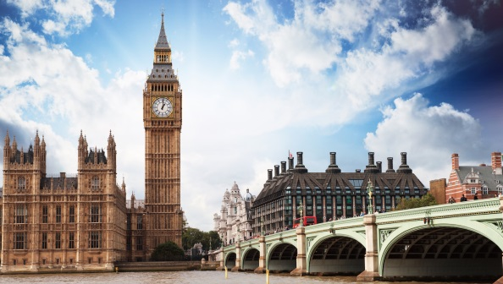
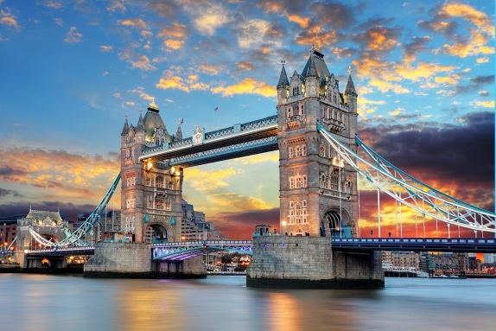
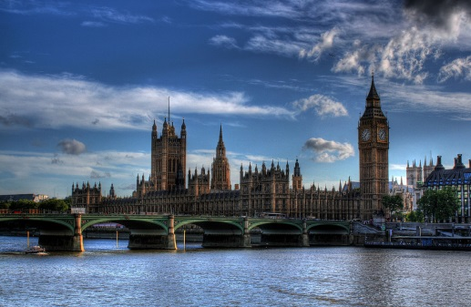
Arrival at Heathrow Airport in London. Transfer to the Hotel. Free lunch. You meet your tour guide at 2.00 pm. Later you have a mini cruise from Westminster to Tower Bridge. We visit the Tower of London, which is a historic castle and we see the famous Tower Bridge, which is London drawbridge, located on the River Thames. It links Southward hamlets and Tower Hamlets. In the evening we have dinner at “Mattarello Restaurant”. Overnight stay in the Hotel.

DAY 2
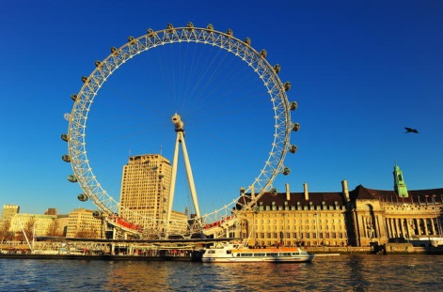
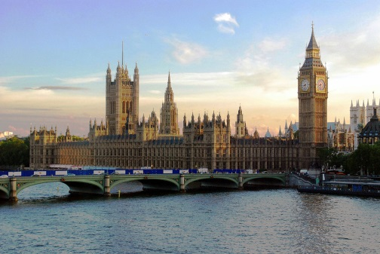
After a full English breakfast, we visit the famous Westminster Bridge, the pedestrian and carriage bridge which crosses the River Thames, located between Westminster on the north bank and Lambeth on the south bank. There will be time for a ride on the London Eye the panoramic wheel to enjoy a splendid view of London. You have lunch in a English restaurant. In the afternoon we visit the Houses of Parliament, Big Ben and Westminster Abbey, the most important Anglican worship site in London after St. Paul’s Cathedral, home to the crowns of England’s sovereigns and burial of important people. Our tour ends with dinner at “Wilton’s”. the oldest restaurant in London. Overnight stay in the Hotel.

DAY 3
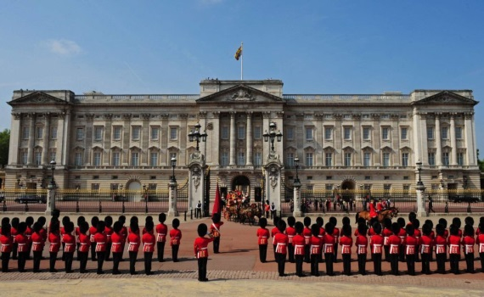
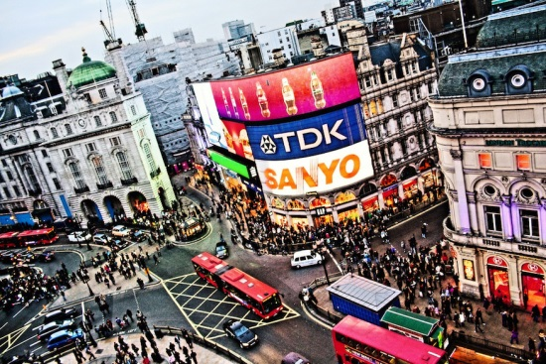
Departure for the fascinating visit to Buckingham Palace. It is the home of the Queen of the UK. Afterwards we visit Piccadilly Circus located in the heart of London’s West End. We walk through the nearby streets like Coventry Street and Haymarket, full of fashionable shops and clubs. Later we go shopping in one of London’s finest department stores “Harrods”, which sells shirts, bags, gadgets and more. After that we visit Hyde Park, which one of the nine Royal Parks in London. You have lunch at “Piccadilly Circus”. In the afternoon, we visit the British Museum, which is one of the largest and most important museums in world history. It was founded in 1753. Later we visit the National Gallery which is an art gallery in Trafalgar Square, founded in 1824. Finally, we visit Trafalgar Square, which is the London square dedicated to the memory of the Battle of Trafalgar. Departure from Heathrow Airport.

