ISTITUTO TECNICO

“CARLO CATTANEO”
San Miniato (PI)

BRITISH HISTORY

BRITISH HISTORY: 600 BC-12TH CENTURY

The Celts arrived in the British Isles about 600 BC. They came from Europe (Germany) and they spoke a Celtic language. They were hunters and farmers and they built stone monuments like Stonehenge. (The Britons, a Celtic tribe, gave Great Britain its name).

In 43 AD the Roman Emperor Claudius conquered Britain. The Romans built roads and cities, including London. In the 2nd century AD Emperor Hadrian built a wall-Hadrian’s Wall –to keep the Scottish tribes out of Roman Britain. Britain remained part of the Roman Empire for 400 years.

When the Romans left Britain at the beginning of the 5th century (410), the island was invaded by the Anglo-Saxons from north-west Germany. The Anglo-Saxons (the Angles, the Saxons and the Jutes) settled in Britain from the 5th century to the 7th century .They spoke Anglo-Saxon (a Germanic language) and introduced their culture and religion in Britain. The Angles gave England its name. The Romans had introduced Christianity for the first time in Britain ,the Anglo-Saxons re-established pagan values. In 597 a monk called Augustine (St. Augustine) was sent to England to convert Britain to Christianity. By the end of the 7th century, Britain was Christian.

At the end of the 8th century, there were invasions by the Vikings from Scandinavia. They spoke Old Norse and they made York the capital of their kingdom.

In 1066 England was invaded by the Normans, led by William the Conqueror .The Normans were from north-west France , spoke French and had French habits. They introduced their language , their culture and the feudal system in England. The Normans remained in Britain for about 100 years. During this period English was the language of the common people, French was the language of the court and government and Latin was the language of science, religion and education.
IMPORTANT DATES
Wales was united to England in 1536.
Scotland was united to England in 1707.
Ireland was united to Britain in 1801.(the United Kingdom of Great Britain and Ireland)
Ireland was divided into two parts: Ulster and Eire (the Republic of Ireland) in 1921. (The United Kingdom of Great Britain and Northern Ireland)
In 1215 the English barons forced king John (John Lackland) to sign the Magna Carta.
This document limited the power of the King and increased the power of the nobility. This document marked the first step towards a constitutional monarchy.
14th Century: Geoffrey Chaucer wrote the Canterbury Tales. He was the first writer to use English (Middle English) as a literary language.

1

HOW BRITAIN BECAME PROTESTANT( 16TH CENTURY)
Henry VIII(1509-1547)wanted to divorce his first wife, Catherine of Aragon ,a Spanish princess, for her failure to produce a son and heir to the throne (she gave him a daughter (Mary I) ).When he fell in love with Anne Boleyn ,a lady of the court, he asked the Pope for permission to divorce Catherine. The Pope refused because he was afraid of offending Charles V of Spain, Catherine’s nephew, who had invaded Rome. In 1534 Henry married Anne Boleyn all the same, broke away from the Church of Rome and set up the Church of England, declaring that he was the Head of the Church of England. England had become a Protestant country. Henry had six wives and three children(Mary I, Edward VI and Elizabeth I)

ELIZABETH I(1558-1603)
Elizabeth I became Queen in 1558,nat the age of 25.She reigned for 45 years and during her reign England became a powerful European state.
Elizabeth I was the daughter of Henry VIII and his second wife, Anne Boleyn. She was a wise politician and she loved history, science, literature, and art. The Elizabethan Age was a period of international trade, exploration, military success, colonisation (The first colony in North America was called Virginia in honour of the Virgin Queen) and artistic development. During this period England built up its Navy and became a great naval power. In 1588 English ships defeated the ships of the Spanish Armada, which were going to attack England. The Queen encouraged the arts: music, poetry and drama. William Shakespeare wrote some of the greatest works in the English language at this time. His sonnets, comedies and tragedies (“Romeo and Juliet”,”Hamlet”..) are famous all over the world. Elizabeth never married but she used this as a diplomatic tool. She used to say she was married to England. Elizabeth died in 1603.Her cousin James VI of Scotland ascended the throne and united the crowns of the two countries.

THE ENGLISH REPUBLIC(1649-1660)-THE STUARTS
Charles I (son of James I ) wanted to rule Britain by his divine right as king. Parliament rebelled against him, and in 1642 the civil war (1642-1649) broke out .The civil war came to an end in 1649, the king was executed and a Republic was set up under the leadership of Oliver Cromwell. The Republic lasted for 11 years. The monarchy was restored under Charles II in 1660.Parliament was now the supreme authority and the power of the monarch was limited.
http://en.wikipedia.org/wiki/List_of_English_monarchs
http://en.wikipedia.org/wiki/List_of_British_monarchs

QUESTIONS
- When did the Celts arrive in the British Isles? Where were they from? What did they build?
- When did the Romans arrive in Britain? Where were they from? What did they build?
- When did the Anglo-Saxons arrive in Britain? Where were they from? What did they introduce in Britain? What language did they speak?
- Who converted Britain to Christianity? When did Britain become Christian?
- When did the Vikings arrive in England? Where were they from? What language did they speak?
- What happened in 1066? Where were the Normans from? Who was their leader? What language did they speak? What did they introduce in Britain?
- What were the three languages used in Britain during this period?
- When were Wales and Scotland united to England? When was Ireland united to Great Britain? When was Ireland divided into two parts?
- Why is 1215 an important date for Britain?
- Why is 1534 an important date for Britain?
- How did Britain become Protestant?
- Why is the Elizabethan period considered a Golden Age for Britain?
- What do you know about Elizabeth I?
- When and why did the Civil War break out? How long did it last?
- What happened in 1649?Who was the leader of the Republic?
- When was the monarchy restored?
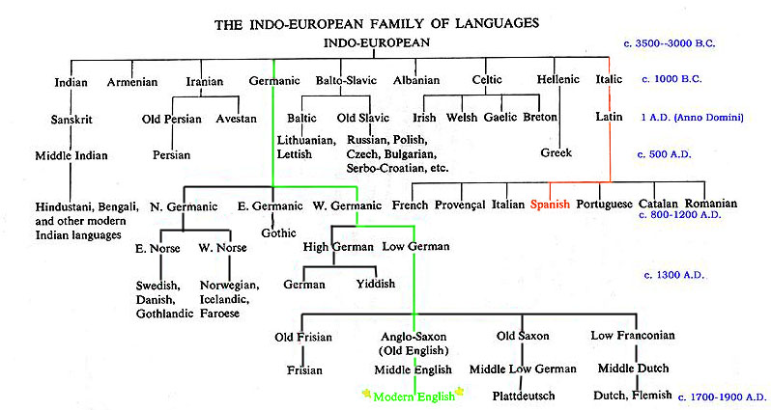
3

THE INDUSTRIAL REVOLUTION

The first stage of the Industrial Revolution took place in the early 18th century. In earlier times, people made products by hand and worked at home. This took quite a long time and the cost of goods was usually high. The cotton industry was an important part of the British economy, but it took a long time to make cotton goods.
Businessmen imported raw cotton from Asia and North America and looked for faster ways of making the cloth. In 1733 John Kay invented the flying shuttle, which cut cotton production time by half. Other inventions, such as the spinning jenny (1770) and the power loom (1785), followed and people began to buy machines, build factories and make cotton products more quickly and cheaply.

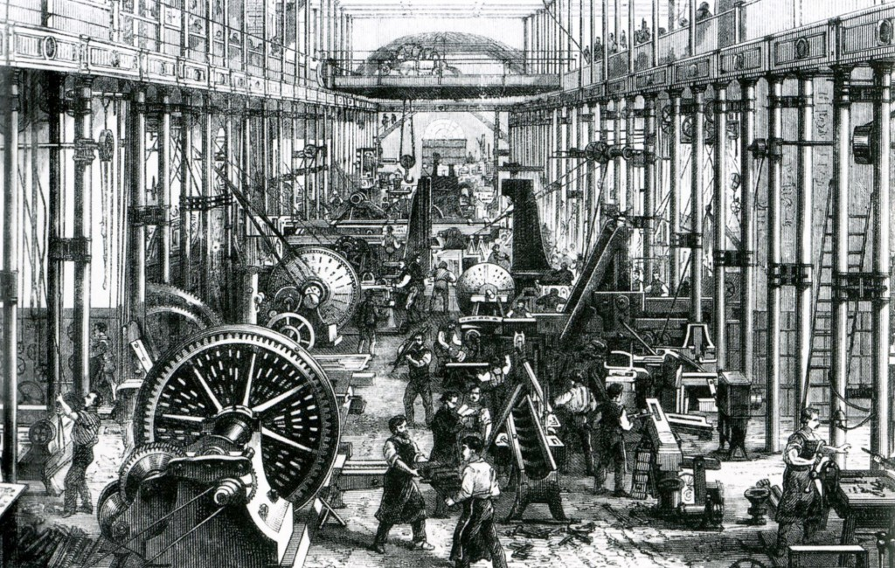

Factories were built in the coal and iron regions of the North of England, the Midlands and South Wales. In 1769 James Watt invented the steam engine and transport became faster.
The second stage of the Industrial Revolution took place in the 1850s .The main inventions were the electric light, the light bulb, the telephone, the telegraph and the radio.

The Industrial Revolution had a great effect on people’s lives: some people became very rich; other people’s lives got worse. The new factories employed women and children, who worked long hours in unhealthy conditions for very low wages. The Industrial Revolution was responsible for an increase in trade and wealth, but it also created many health problems and pollution.

QUEEN VICTORIA

Queen Victoria was Britain‘s longest- serving sovereign. She ruled for 64 years .She ascended the throne in 1837 and she died in 1901.Her father was the fourth son of George III ;she became Queen because her three uncles had no heirs .
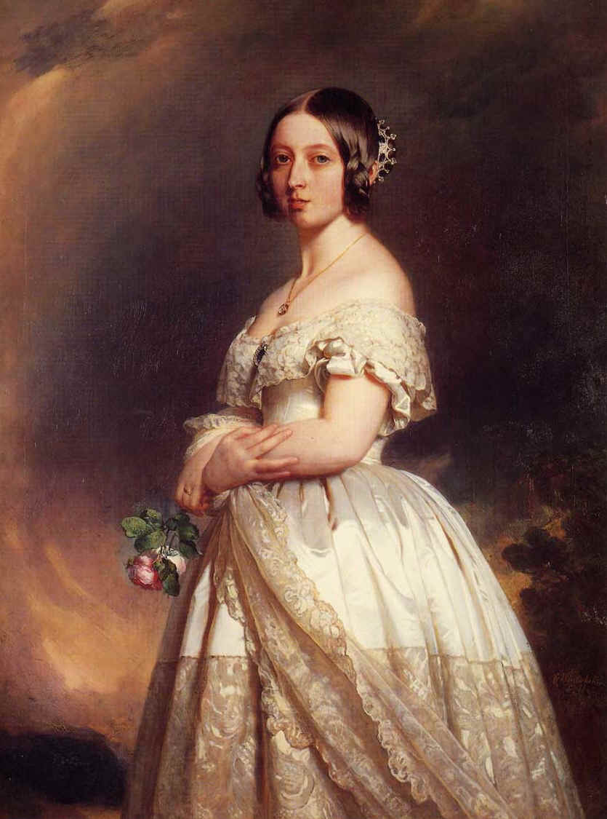
She became Queen at the age of 18; she took her duties seriously and worked closely with her Prime Ministers. After her marriage to Prince Albert of Saxe-Coburg and Gotha in 1840, she relied very heavily on his advice. Queen Victoria and Albert had nine children and a happy marriage (Albert died in 1861).
During her reign, the monarchy became a symbolic institution as it is today. Queen Victoria was the very first constitutional Queen.
Britain became more democratic: Parliament gave the right to vote to 60% of all British men. Education became free and compulsory from the age of five to the age of twelve (1870). Schools were built all over the country.
The Victorian Age was a period of great colonial expansion. Britain founded colonies in Africa and India. Queen Victoria was named Empress of India in 1876. New inventions such as the electric light, the light bulb, the telephone, the telegraph and the radio were developed.
When Queen Victoria died in 1901, Britain was one of the richest countries in the world.

THE 20th CENTURY and THE 21st CENTURY

THE FIRST WORLD WAR (1914-1918)

At the beginning of the twentieth century, there was a lot of friction between Germany and other European powers, especially Britain.
The First World War broke out in 1914 because Archduke Francis Ferdinand of Austria was assassinated by a Serbian nationalist in Sarajevo in June 1914.Austria-Hungary declared war on Serbia and Russia mobilised its army to defend Serbia. Germany then declared war on Russia and France, Russia’s ally. When Germany invaded Belgium to attack France, Britain entered the war. Europe organised itself into two camps: The Central Powers (Austria-Hungary, Germany and Turkey) and the Allies (France, Great Britain, Italy (1915), Japan and Russia).
Russia left the war in 1917 because of the October Revolution in Russia. The USA entered the war in 1917 because German submarines attacked American ships.
After four years (1918) the Allies succeeded in defeating the Central Powers. The armistice was signed on 11 November 1918.The Peace Treaty was made in Versailles in 1919.

THE 1920s AND THE 1930s

Ireland
With the end of the First World War the Irish Question rose again and in 1921 Ireland was divided into two parts: Ulster, which remained part of the UK, and the Irish Free State, later called Eire.
The Great Depression
Hard times followed the end of the First World War for Britain’s economy. There was the decline of the old industries like coal, cotton, iron and shipbuilding. Workers lost their jobs and Trade Unions organized strikes.
A period of Great Depression started in Europe and in the USA, which culminated in the Wall Street Crash in October 1929.
In 1929 the Labour Party won the British general elections and faced the problems of unemployment.
The worldwide economic depression and unemployment combined with some international factors, such as the creation of the first Socialist State after the Russian Revolution of 1917 and the rise of Fascism in Italy (1922) and Nazism in Germany (1933),shifted the political attitudes of many intellectuals and artists to the left in the 1930s.In 1936 the Spanish Civil War broke out and many of them went to Spain to fight on the side of the Republicans against General Franco ,the symbol of dictatorship, who was allied with Italy and Germany.
Women over the age of 21 were granted the right to vote in 1928.

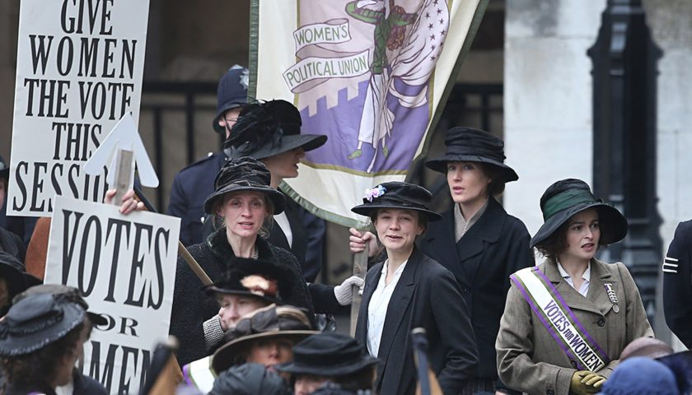

THE SECOND WORLD WAR (1939-1945)
In 1939, when Hitler invaded Poland, the UK and France declared war on Germany to defend Poland. This was the beginning of the Second World War. The war eventually spread to include almost the whole world.
In 1940 Germany conquered France and most of Europe but lost the Battle of Britain (Under the leadership of Sir Winston Churchill, Prime Minister, the pilots of the Royal Air Force won the Battle of Britain against German planes-the German Luftwaffe), so it was unable to invade the UK.
Russia came in when Hitler attacked Russia in 1941.The USA entered the war when Japan bombed its naval base at Pearl Harbour in Hawaii in 1941.Germany, Italy and Japan were known as the Axis Powers and the UK, the USA, France and Russia were known as the Allies.
The war in Europe came to an end with the defeat of Nazi Germany in May 1945 .The war in the Pacific came to an end in August 1945 when the USA dropped atomic bombs on two Japanese cities: Hiroshima and Nagasaki. An armistice was signed on September 2nd, 1945.

THE LAST SEVENTY YEARS

After the Second World War, the Labour Party governed Britain and created the Welfare State, a social security system to protect the poor and the needy, guaranteeing a home, medical care, food and education for everyone. The Labour Party nationalised many industries. The industries, which served the population, came under state control. These industries included the Bank of England, coal and iron mining, steel production, electricity and transport.
The UNO was set up in 1945 and the NATO was set up in 1949.In 1947 India and Pakistan became independent and in the 1960s most African colonies became independent, too.(Now Britain has only two colonies: Gibraltar and the Falklands)
In 1952 George VI died and his daughter, Elizabeth II, became Queen.
In 1973 Britain joined the EEC (1957), which became the EU in 1992.In 1979 the Conservative leader, Margaret Thatcher, became Britain’s first woman Prime Minister. Margaret Thatcher governed Britain for 11 years. Under Margaret Thatcher, the government privatised the nationalised industries (They reduced the role of the State) and favoured a free market economy.
The Conservative Party kept control of the government until 1997.
In 1991 Britain took part in the Gulf War. In 1997 Tony Blair, leader of the Labour Party, became Prime Minister. Tony Blair did not join his European partners when in January 1999 they officially adopted the Euro as a common currency.
In 2001 Tony Blair was re-elected. A few months after his victory (11 September 2001) he was confronted with the tragedy of the attack on the Twin Towers of the World Trade Center in New York and the Pentagon in Washington. He did not hesitate for a second: he sided with the USA and it was war against Afghanistan, the Taliban and Osama Bin Laden.
2002 was an important year for the Queen. She lost her mother, Elizabeth, and her sister, Margaret, and she celebrated her Golden Jubilee (50 years of reign).
In March 2003 the UK joined the military campaign against Iraq (the Iraq War).
In 2005 Tony Blair was re-elected. Gordon Brown became Prime Minister in 2007.He belonged to the Labour Party. David Cameron, leader of the Conservative Party, is the present Prime Minister. He was elected in 2010. He was re-elected in 2015.
In 2012 Elizabeth II celebrated her Diamond Jubilee (60 years of reign) and Britain hosted the Olympic Games. Prince George, the Royal baby and heir to the throne was born in July 2013.He is Prince William and Kate Middleton’s son. Their daughter, Charlotte Elizabeth Diana, was born in 2015 and their third son was born in 2018. Queen Elizabeth II has now reigned for 68 years, breaking the record for Britain’s longest-serving sovereign.
A referendum took place in June 2016 and 52% voted in favour of leaving the European Union. David Cameron, who called the referendum and campaigned for Britain to remain in the EU, resigned on July 13.Theresa May was elected in 2016.She belonged to the Conservative Party. Boris Johnson, who is the leader of the Conservatory Party, is the present Prime Minister. He was elected in 2019.The United Kingdom left the European Union in 2020.

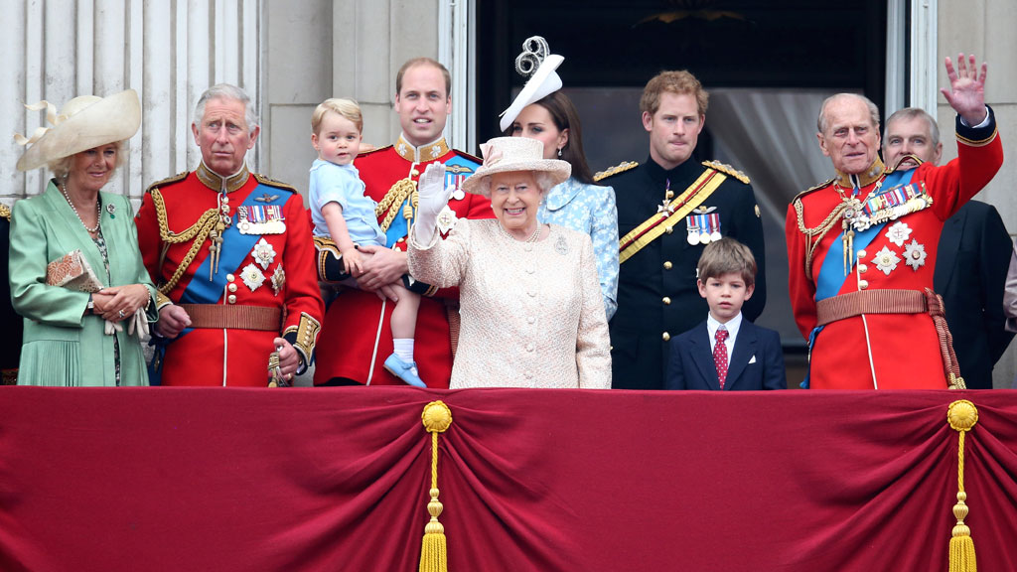

BRITISH HISTORY

QUESTIONS

THE INDUSTRIAL REVOLUTION

1) When did the first stage of the Industrial Revolution take place?
2) When did John Kay invent the flying shuttle? Why was this invention important?
3) When did James Watt invent the steam engine? Why was this invention important?
4) What were the main inventions?
5) When did the second stage of the Industrial Revolution take place? What were the
main inventions ?
QUEEN VICTORIA

- When did Queen Victoria ascend the throne? When did she die?
- How long did she reign?
- Why was Queen Victoria’s reign significant in British history?
- Where were the main colonies set up?
- What were the main inventions during this period?
- When was Queen Victoria named Empress of India?

THE 20th CENTURY and THE 21st CENTURY

- When did the First World War break out and for what reason?
- When did Russia retire from the war?
- Why did the USA enter the war in 1917?
- How long did the war last?
- When were the Central Powers defeated?
- When was the armistice signed? When and where was the Peace Treaty made?
- What happened in Britain in the 1920s and 1930s?
- When did Germany invade Poland?
- What did France and the UK do to defend Poland?
- When did the USA and Russia enter the war? Why?
- When and how did the war come to an end in Europe and in the Pacific?
- Which political party did the British vote into government after the Second World War?
- What did the Labour Party create?
- When did India become independent?
- When did Elizabeth II become Queen?
- When did Britain join the EEC?
- When did Margaret Thatcher become Prime Minister? How long did she govern Britain? Which political party did she belong to?
- When did Tony Blair become Prime Minister? Which political party did he belong to?
- Why was 2002 an important year for the Queen?
- When did Gordon Brown become Prime Minister? Which political party did he belong to?
21) When did David Cameron become Prime Minister? Which political party does he belong
to?
22) Who is the present Prime Minister? Which political party does he belong to?

AMERICAN HISTORY

THE FIRST WORLD WAR
(vedi anche BRITISH HISTORY)

America became involved in the First World War (1914-1918) in April 1917. The country entered the war on the Allied side when German submarines attacked American ships. With the American help, the war quickly came to an end in October 1918.

THE WALL STREET CRASH, THE GREAT DEPRESSION AND THE NEW DEAL

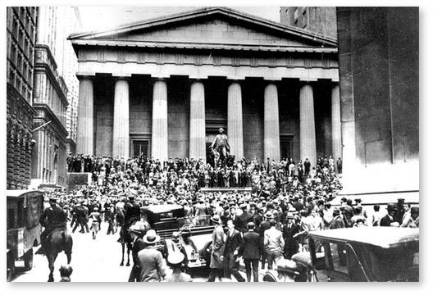
In the USA the 1920s was a period of great prosperity. General prosperity came to a sudden end in 1929 because there was a massive crash on the stock market, the Wall Street Crash. This financial disaster was followed by years of economic depression –the Great Depression .By 1932 about 12 million people were out of work. Franklin Delano Roosevelt (1933-1945) became president in 1933 and introduced the New Deal, a package of social and economic reforms, in order to revive the American economy and put people back to work.

THE SECOND WORLD WAR
(vedi anche BRITISH HISORY)

In 1939 Europe went to war again .At first the Americans did not want to get involved in another European conflict .However, in 1941, the Japanese attack on Pearl Harbour, Hawaii precipitated their decision and the Americans joined the Allies. The Second World War came to an end in August 1945 when the USA dropped two atomic bombs on Hiroshima and Nagasaki bringing the war with Japan to an end.
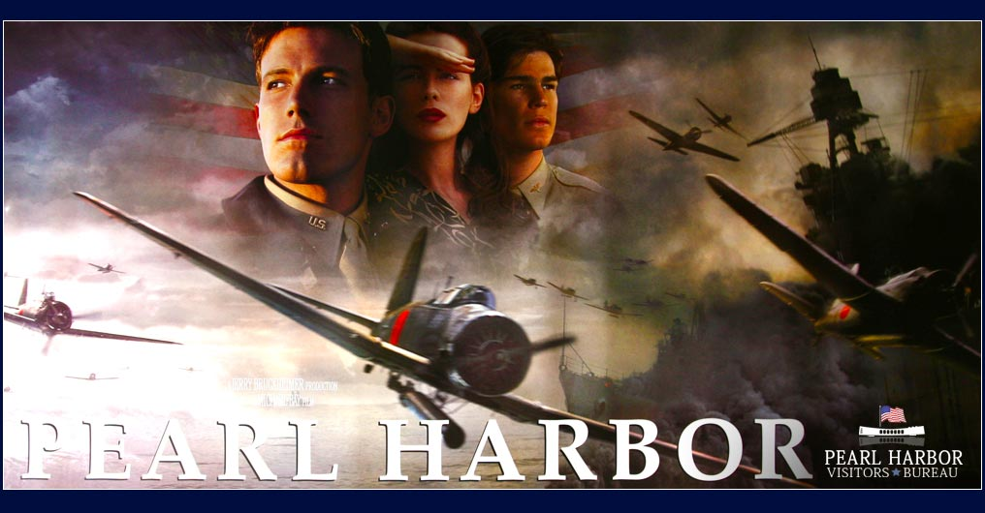

THE UNO AND THE NATO
(vedi anche altra fotocopia)

The UNO was set up in 1945 to promote world peace and cooperation between nations. The NATO was set up in 1949 to defend any member state from acts of aggression.(It created a defensive and political alliance of European states, Canada and the USA.)

THE COLD WAR (1945-1990)

After 1945 attitudes changed. America was stronger than any other nation, economically and militarily. It saw itself as the leader of the ”free world” and was determined to combat the growing threat of Communism and the Soviet Union .A war-tired Europe provided the ideal ground for Communist expansion. In order to prevent this growth, in 1948 President H. Truman (1945-1953) set up the Marshall Plan, which gave food and resources to European countries to keep them away from Communism. By 1952 the Plan had worked. Europe was back on its feet again economically and tied politically to the USA.
The 1950s was a decade of rivalry between the USA and the Soviet Union. The conflict and tension between these two nations was known as the Cold War ( a period of great political tension between the USA and the Soviet Union.).The Cold War pushed the USA to become involved in conflicts with other countries to gain political control against Communism and the Soviet Union.
From 1950 to 1953 the USA fought successfully to prevent Communist North Korea from taking over South Korea.(the Korean War had broken out when Communist North Korea had invaded South Korea.)
In 1961 John F. Kennedy supported the Bay of Pigs invasion of Cuba by exiles to end Fidel Castro’s communist regime. The invasion failed. In 1962 the Soviets placed nuclear missiles on the island of Cuba, their new ally-, just a few miles from the US coast. There were fears of nuclear war but President Kennedy (1960-1963) persuaded them to remove the weapons. John F. Kennedy was assassinated in Dallas, Texas, in 1963.
The USA became involved in Vietnam because the Americans wanted to prevent Communist North Vietnam from taking over South Vietnam.(North Vietnam was controlled by a Communist regime, under Ho Chi Minh, while South Vietnam was under a democratic government .The war had broken out when Ho Chi Minh had invaded South Vietnam in an attempt to unify the country.)The Americans left Vietnam in 1973 but the war really ended in 1975 when South Vietnam fell under the control of the North Vietnamese and North Vietnam reunited the country. (The Vietnam War (1964-1975) ) .
In 1987 the American President Ronald Regan and the Soviet leader Mikhail Gorbachev signed a peace treaty agreeing to destroy all their nuclear missiles.
The Cold War ended in the early 1990s with the collapse of Communism. It had lasted over 40 years.
THE 1990S AND THE EARLY 2000S

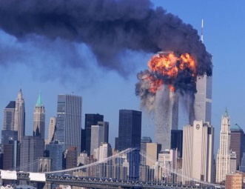
In 1991, President George Bush led a NATO attack against the Iraqi forces that had invaded Kuwait in order to gain control of their oil fields. The resulting military operation was successful.(The Gulf War)
On 11 September 2001 the Pentagon in Washington and the Twin Towers of the World Trade Center in New York were attacked. A month later , with the support and help of the NATO Allies, war was declared against Afghanistan, the Taliban and Osama Bin Laden ,the man accused of organising the September 11 attacks .Eventually, the Taliban were defeated. Osama Bin Laden was executed in 2011.

In 2003 the USA and its Allies launched a devastating series of air attacks on Baghdad and Iraq designed to force Iraq to submit (The Iraq War).It was believed that Saddam Hussein had links to Al Qaeda, the terrorist group responsible for the attacks on the Twin Towers and he was also amassing an arsenal of weapons of mass destruction to launch an attack on the West. The war ended successfully for the USA and its Allies, but the weapons of mass destruction were not found. Saddam Hussein was captured alive in December 2003. He was executed in December 2006.
In 2004 George W. Bush (2000-2008) was re-elected President. Barack Obama is the 44th and current President of the USA and is the first African American to hold the office. He was elected President in 2008 and he was re-elected in 2012.He was awarded the Noble Prize in 2009. Donald Trump was elected President of the USA in 2017.He belongs to the Republican Party. John Biden is the 46th President of the USA. He was elected in 2020. He belongs to the Democratic Party.

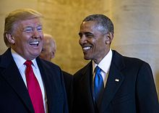

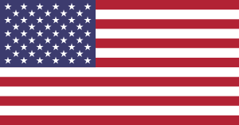

AMERICAN HISTORY

QUESTIONS

- When and why did the USA enter the First World War? When did the Allies defeat the Central Powers?
- Which countries did the Allies include?
- Which countries were the Central Powers made up of?
- Who was the President of the USA during this period? (W. Wilson- 1913-1921)
- Why were the 1920s an important period for the USA?
- When and why did general prosperity come to an end?
- What was the Wall Street Crash followed by?
- When did Franklin D. Roosevelt become president?
- What did he introduce in order to revive the American economy?
- What was the New Deal?
- When and why did the USA enter the Second World War?
- Who was the President of the USA in 1941?
- When and how did the war come to an end in the Pacific?
- Who was the President of the USA in 1945? (H. Truman)
- Who was the British Prime Minister from 1940 to 1945? (W. Churchill)
- When was the UNO set up? Why?
- When was the NATO set up? Why?
- Which country was the richest and most powerful country in the world after the Second World War?
- What did the USA want to combat?
- What did President Truman do to prevent Communist expansion?
- Why were food and resources given to European countries?
- When did the Cold War begin?
- What was the Cold War?
- What was the USA’s contribution to the Korean War?
- Why did the Korean War break out?
- Why is the Bay of Pigs considered one of the “most serious crises” of the Cold War?
- When and where was J. F. Kennedy assassinated?
- Why did the USA become involved in Vietnam?
- When did the Americans leave Vietnam? When did the war really end?
- When and how did the Cold War come to end?
- When did the Gulf War break out and for what reason?
- What happened on 11 September 2001? Who was Osama Bin Laden?
- When was he executed?
- What happened in 2003?
- When was Saddam Hussein captured? When was he executed?
- When was George W. Bush re- elected?
- When was B. Obama elected?
- Who is the present President of the USA?

