British History(600 BC-12th century)

The Celts arrived in the British Isles about 600 BC. They came from Europe (Germany) and they spoke a Celtic language. They were hunters and farmers and they built stone monuments like Stonehenge. (The Britons ,a Celtic tribe, gave Great Britain its name).

In 43 AD the Roman Emperor Claudius conquered Britain . The Romans built roads and cities, including London. In the 2nd century AD Emperor Hadrian built a wall-Hadrian’s Wall –to keep the Scottish tribes out of Roman Britain. Britain remained part of the Roman Empire for 400 years.

When the Romans left Britain at the beginning of the 5th century(410),the island was invaded by the Anglo-Saxons from north-west Germany. The Anglo-Saxons (the Angles, the Saxons and the Jutes) settled in Britain from the 5th century to the 7th century .They spoke Anglo-Saxon (a Germanic language) and introduced their culture and religion in Britain. The Angles gave England its name. The Romans had introduced Christianity for the first time in Britain ,the Anglo-Saxons re-established pagan values. In 597 a monk called Augustine( St. Augustine ) was sent to England to convert Britain to Christianity. By the end of the 7th century Britain was Christian.

At the end of the 8th century there were invasions by the Vikings from Scandinavia.They spoke Old Norse and they made York the capital of their kingdom.

In 1066 England was invaded by the Normans ,led by William the Conqueror .The Normans were from north-west France , spoke French and had French habits. They introduced their language , their culture and the feudal system in England. The Normans remained in Britain for about 100 years. During this period English was the language of the common people, French was the language of the court and government and Latin was the language of science, religion and education.
Important dates
Wales was united to England in 1536.
Scotland was united to England in 1707.
Ireland was united to Britain in 1801.(the United Kingdom of Great Britain and Ireland)
Ireland was divided into two parts: Ulster and Eire (the Republic of Ireland) in 1921. (the United Kingdom of Great Britain and Northern Ireland)
In 1215 the English barons forced king John ( John Lackland) to sign the Magna Carta.
This document limited the power of the King and increased the power of the nobility. This document marked the first step towards a constitutional monarchy.
14th Century: Geoffrey Chaucer wrote the Canterbury Tales. He was the first writer to use English (Middle English) as a literary language.

1

How Britain became Protestant( 16th century)
Henry VIII(1509-1547)wanted to divorce his first wife, Catherine of Aragon ,a Spanish princess, for her failure to produce a son and heir to the throne (she gave him a daughter (Mary I) ).When he fell in love with Anne Boleyn ,a lady of the court, he asked the Pope for permission to divorce Catherine. The Pope refused because he was afraid of offending Charles V of Spain, Catherine’s nephew, who had invaded Rome. In 1534 Henry married Anne Boleyn all the same, broke away from the Church of Rome and set up the Church of England. declaring that he was the Head of the Church of England. England had become a Protestant country. Henry had six wives and three children(Mary I, Edward VI and Elizabeth I)

Elizabeth I(1558-1603)
Elizabeth I became Queen in 1558,at the age of 25.She reigned for 45 years and during her reign England became a powerful European state.
Elizabeth I was the daughter of Henry VIII and his second wife ,Anne Boleyn. She was a wise politician and she loved history, science, literature and art. The Elizabethan Age was a period of international trade ,exploration, military success, colonisation (The first colony in North America was called Virginia in honour of the Virgin Queen) and artistic development. During this period England built up its Navy and became a great naval power. In 1588 English ships defeated the ships of the Spanish Armada , which were going to attack England. The Queen encouraged the arts :music , poetry and drama. William Shakespeare wrote some of the greatest works in the English language at this time. His sonnets, comedies and tragedies (“Romeo and Juliet”, ”Hamlet”..) are famous all over the world. Elizabeth never married but she used this as a diplomatic tool. She used to say she was married to England. Elizabeth died in 1603.Her cousin James VI of Scotland ascended the throne and united the crowns of the two countries.

The English Republic(1649-1660)-The Stuarts
Charles I ( son of James I ) wanted to rule Britain by his divine right as king. Parliament rebelled against him, and in 1642 the civil war(1642-1649) broke out .The civil war came to an end in 1649, the king was executed and a Republic was set up under the leadership of Oliver Cromwell. The Republic lasted for 11 years. The monarchy was restored under Charles II in 1660.Parliament was now the supreme authority and the power of the monarch was limited.
http://en.wikipedia.org/wiki/List_of_English_monarchs
http://en.wikipedia.org/wiki/List_of_British_monarchs

Questions
- When did the Celts arrive in the British Isles? Where were they from? What did they build?
- When did the Romans arrive in Britain? Where were they from? What did they build?
- When did the Anglo-Saxons arrive in Britain ? Where were they from? What did they introduce in Britain? What language did they speak?
- Who converted Britain to Christianity? When did Britain become Christian?
- When did the Vikings arrive in England? Where were they from? What language did they speak?
- What happened in 1066?Where were the Normans from? Who was their leader? What language did they speak? What did they introduce in Britain?
- What were the three languages used in Britain during this period?
- When were Wales and Scotland united to England? When was Ireland united to Great Britain? When was Ireland divided into two parts?
- Why is 1215 an important date for Britain?
- Why is 1534 an important date for Britain?
- How did Britain become Protestant?
- Why is the Elizabethan period considered a Golden Age for Britain?
- What do you know about Elizabeth I?
- When and why did the Civil War break out? How long did it last?
- What happened in 1649?Who was the leader of the Republic?
- When was the monarchy restored?
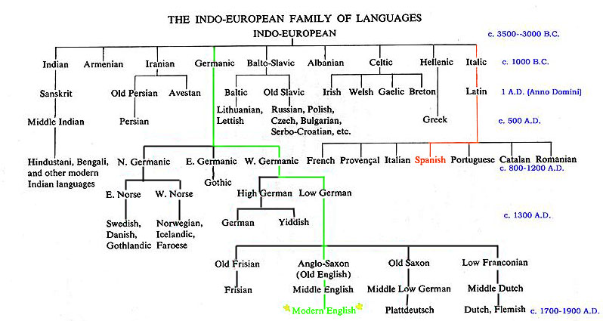
3

