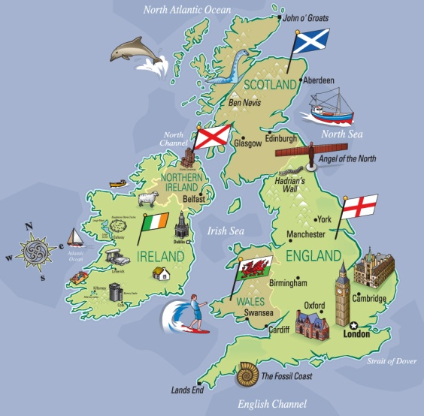
TOUR OF LONDON
London is the capital city of England and the UK. This tour is perfect for a group of 50 year-old people.
3 days (2 nights)
From 550 €
Fly from Pisa airport
WHAT’S INCLUDED:
- Arrival at Gatwick Airport
- Departure from Gatwick Airport
- Transfer between airport and accommodation
- Double rooms
- 2 nights at 4 & 5 star Luxury Hotel in London.
- English – speaking tour guide on tour
- All sightseeing tours as mentored: Westminster, the Houses of Parliament, Big Ben, Buckingham palace, Piccadilly circus and much more
- Travel on tour by minibus or coach
- All local and airport taxes/service charges
Your itinerary day by day
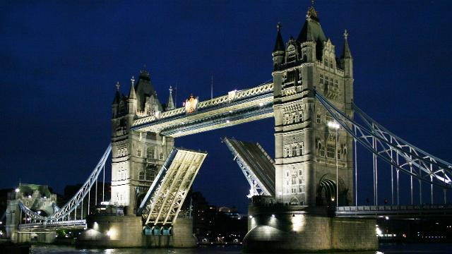

DAY 1.
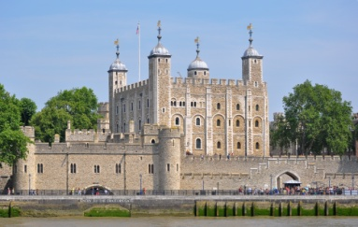
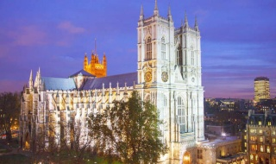
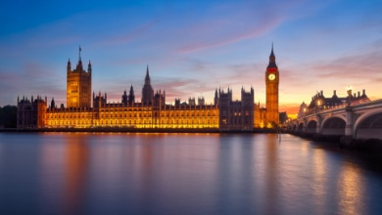
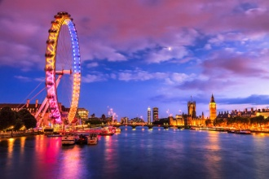
Our walking tour starts with the visit to Tower Bridge which stands on the river Thames. It is a drawbridge which can be raised to let ships pass through. After the visit we head off to the Tower of London, which is an old Norman fortress and it is guarded by Beefeaters in traditional Tudor Uniforms. The Crown Jewels are on show here. Our tour continues with the visit to Westminster Abbey. Unfortunately we have no time to go inside. Westminster Abbey is one of the oldest buildings in London and one of the most important religious centres in the country. Next to Westminster Abbey we can see the Houses of Parliament, which is the place where the House of Lords and the House of Commons meet to discuss and pass laws. You can also enjoy Big Ben which is the landmark of London, and is the nickname of the bell in the clock tower next to the Houses of Parliament. We have lunch and after that there is time to take photos. Our tour continues with the visit to the London Eye, which is the world’s highest observation wheel from which you can get a breathtaking view of London. Overnight stay in the Hotel.

DAY 2.
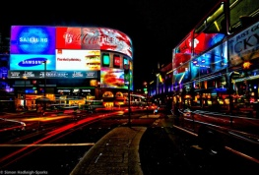
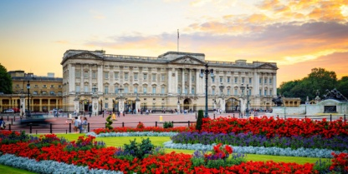
Our tour starts with the visit to Buckingham Palace, the official residence of the Queen and the Royal Family. We can see the Changing of the Guard at the gates of Buckingham Palace at 11.30. From here it is easy to reach Piccadilly Circus. If you like shopping, London is the place where to go! In this square we will find thousands of shops and department stores. In the centre of this square there is the statue of Eros. Don’t forget to pay a visit to Harrods, the largest department store in Europe. After that we have lunch in a famous restaurant where you can taste typical London food such as fish and chips. Afterwards we have free time for shopping. We leave you enjoy your afternoon at leisure. We end our tour with dinner in the hotel. Overnight stay in the hotel.

DAY 3.
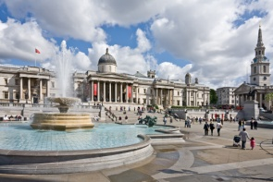
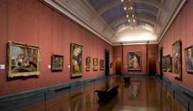
Our tour starts with the visit to the British Museum. We leave the hotel and we take the tube to reach the museum. It’s the largest and richest museum in the world and It contains one of the world’s richest collections of antiquities. We have lunch in a restaurant and after that we reach Trafalgar Square, which was named after Horatio Nelson’s victory over Napoleon. In the north side of the square we can admire the National Gallery which contains a collection of paintings from the 13th century to this century. Our tour ends with a walk in Hyde park, also called the “people’s Park”. It is used for every kind of public occasion. Departure from Gatwick Airport. We arrive at Pisa Airport at 9.30 p.m.
