TREASURES OF LONDON
London is the perfect city for relaxing a holiday .
WHAT’S INCLUDED:
- Departure from Pisa airport at 8.00 a.m.
- Arrival at airport at 10.00 a.m.
- 4 days and 3 nights (10 june 2018 to 14 june 2018)
- Flight on the London Eye
- Panoramic sight of the icons of London
- Fast entry tickets for museums with a professional English speaking tour guide
- Travel on tour by minibus
- London house hotel, in the heart of London
- Price per person : 500€
YOUR ITINERARY DAY BY DAY
Day 1
Departure from Pisa airport at 8.00 a.m. and arrival at Gatwick airport at 10.00 a.m.
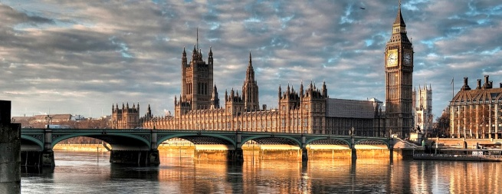
Our walking tour starts whit the visit to the Houses of Parliament which stands on the north bank of the river Thames and is the place where the House of Commons and the House of Lords meet to discuss and pass laws.
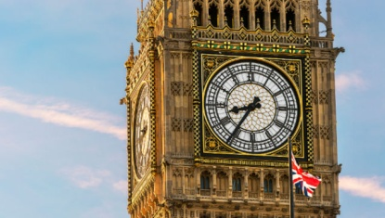

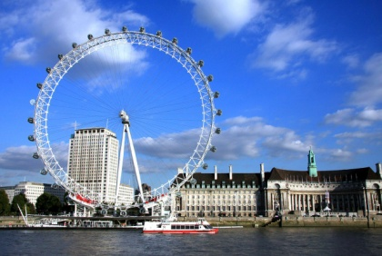
From here it is easy to reach Big Ben, the landmark of London. It is the nickname of the bell in the clock tower next to the Houses of Parliament.

We can continue our tour towards the London Eye which is the world’s highest observation wheel, towering 135 metres.

we have packed lunch for lunch

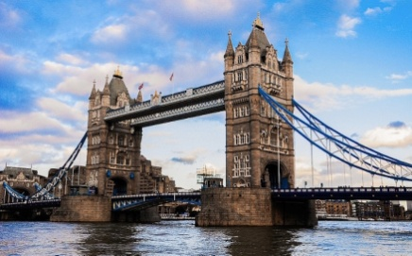
Later on we can visit the Tate Modern , the most visited museum of modern and contemporary art in London .
After words we head to Tower Bridge and on the famous tower of London which is the old Norman fortress built by William the Conqueror
Dinner and overnight stay at the hotel .
Day 2
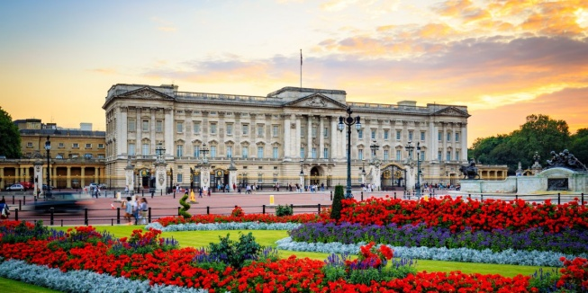
In the morning after breakfast in the hotel we head for Buckingham Palace the royal residence of the royal family we watch the Changing of the Guard, a ceremony famous all over the world

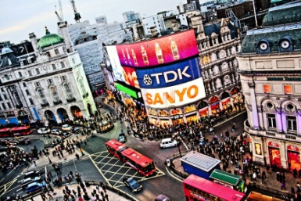
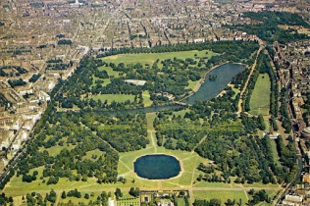
Have lunch and we can relax in Hyde Park, one of the most beautiful parks in London.
From here it is easy to reach Piccadilly, the most beautiful and lovely area in London where we can buy souvenirs. You will find thousands of shops.
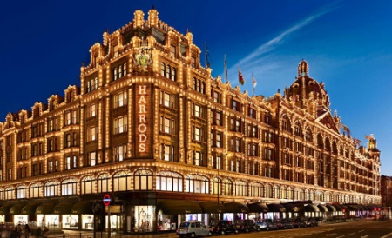
Enjoy your free time to explore the best London shops in Oxford Street and Bond Street.
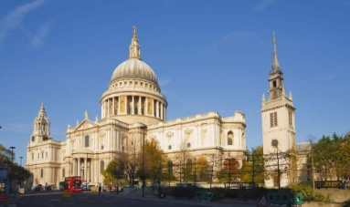
Don’t forget to pay a visit to Harrods and Selfridges the largest department stores in Europe.
After that we visit St Paul’s Cathedral Nelson and Wellington’s Tombs
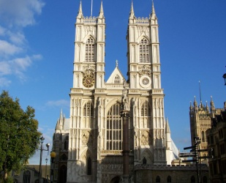
Before dinner we visit Westminster Abbey which is one of the oldest buildings in London and one of the most important religious centrein the country.
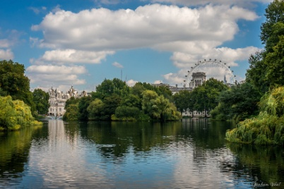
we will have dinner in the centre of the city and after that we walkin St. James Park.
Overnight stay in the hotel,

Day 3
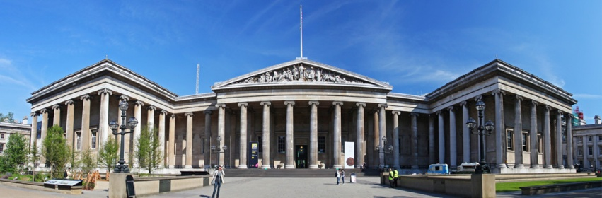
Our walking tour starts with the visit to the British Museum which was founded in 1753 and contains one of the world’s richest collections of antiquities, It contains the Egyptian Galleries which house human and animal mummies and the Rosetta Stone .
we suggest typical food , you have lunch in the restaurant near the museum .
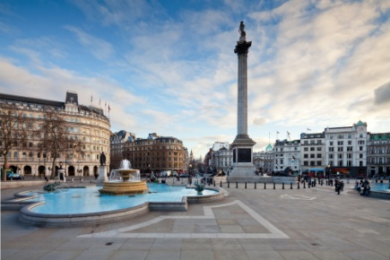
After lunch we visit the National Gallery which stands on the north side of Trafalgar Square. It contains a collection of paintings from the 13th centuryes to this century.
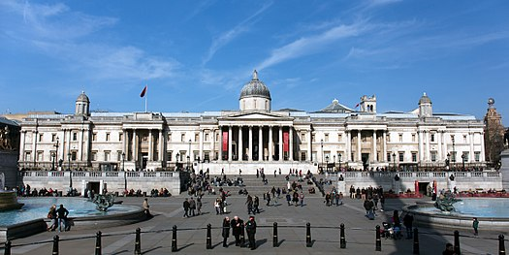

Day 4
Transfer by bus to Gatwick airport at 9.00 and arrival at Pisa airport at 11.30 a.m.

