London.
Ilaria Orlacchio, 5AT.
London, situated on the river Thames in the south-east of Britain, is not only the business and political capital of Great Britain but is also a beautiful and impressive city full of magnificent buildings to see and dynamic places where to have fun.
4 DAYS WHAT’S INCLUDED
From Arrival at Pisa airport
700€ per person Departure from Pisa airport
FLY Transfer between airport and
From your local airport accomodation
3 nights in the hotel
Double and triple rooms
Tour guide on tour
Travel on tour by minibus or coach

DAY 1.
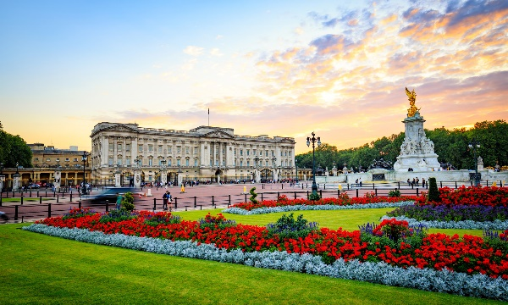
Transfer from Heathrow Airport to the Turner Hotel by coach. Accomodation at the hotel.
Our tour begins with the visit to Buckingham Palace, the official London residence of the Royal Family. You can see the Changing of the Guard at the gates of the palace at 11.30 every morning. We next see St. James Park, the most ancient of the Royal city parks. During the tour, we will stop at a local restaurant for lunch. Our walk continues towards the Houses of Parliament, which consists of the House of Common and the House of Lords. This building is near the charming Big Ben, a symbol of London. We recommend you Covent Garden, a fashionable and stylish place with a lot of shops. From here it’s easy to reach Westminister Abbey where you can see the Stone of Scone. After dinner we reach the London Eye, the world’s highest observation wheel, and we will enjoy a short cruise on river Thames. Overnight stay at the hotel.
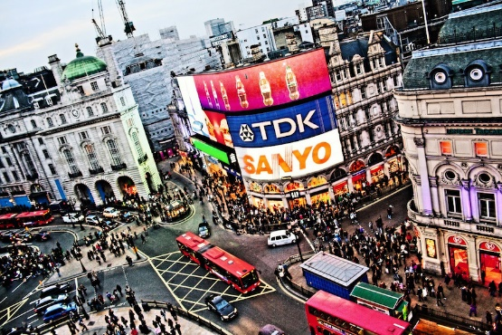
DAY 2.
After breakfast we leave west for Trafalgar Square, where we can admire Nelson’s Column which commemorates Honoratio Nelson’s victory over Napoleon at Trafalgar in 1805. We next reach Piccadilly Circus, the centre of London’s entratainment world, where you can see many cinemas, theatres, restaurants, discos and nightclubs. Leaving Piccadilly Circus we head for Regent’s street and Oxford street where you can go shopping. Later you can eat your packed lunch at Hyde Park. Our tour ends around dinner time. Overnight stay at the hotel.
DAY 3.
On the third day we will visit Madame Tussaud’s, a funny and impressive museum collecting a great number of wax statues which reproduce famous characters of past and present time. We suggest you visit the Planetarium, too, and then have a walk and the lunch in Regent’s Park. After lunch there is time for photos and later you will have a chance to visit the city and go shopping. Dinner and overnight stay at the hotel.
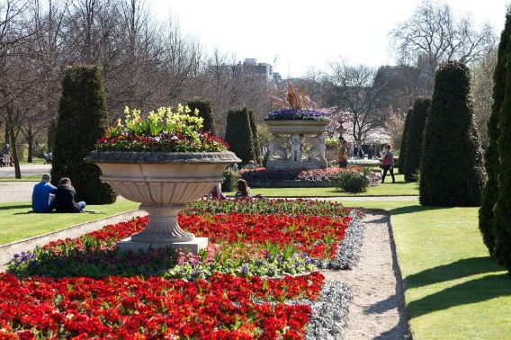
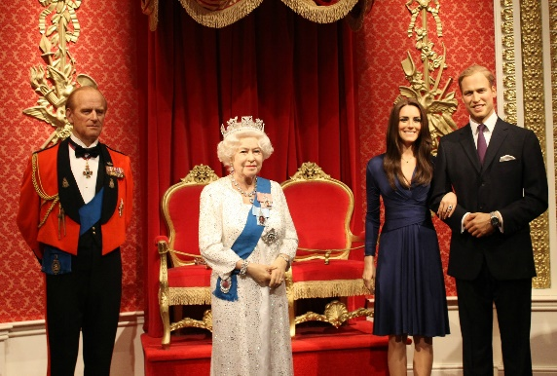

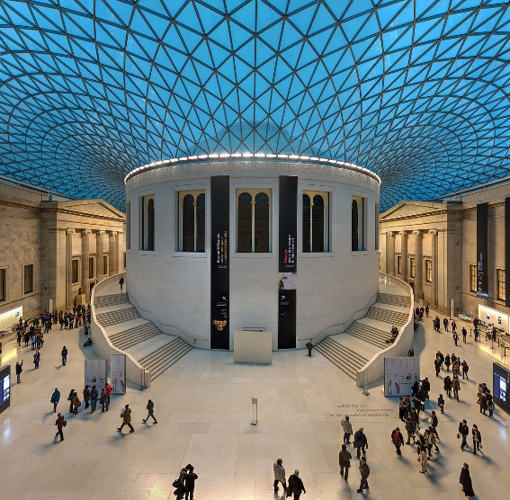
DAY 4.
On the last day we will visit the British Museum, which contains an incredible collection of treasures, such as the Rosetta Stone and two original copies of the Magna Charta. Then we reach St. Paul’s Cathedral, built by Sir Cristopher. You will have lunch at the Savoy Restaurant Hotel. In the afternoon you will leave from Gatwick Airport.

