LONDON
• Arrival at Heathrow Airport
• Departure from Heathrow Airport
• Transfer between airport and accomodation
• (3 days) in Turner Hotel (triple room)
• English-speaking tour guide on tour
• Travel on tour by minibus or coach
• Prices: 700€ per person
London is the best city for all the people who want to visit a beautiful city.
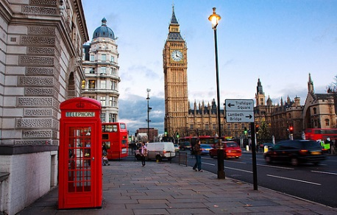
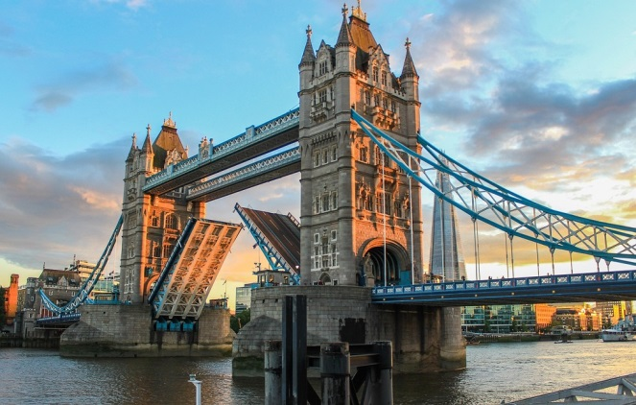
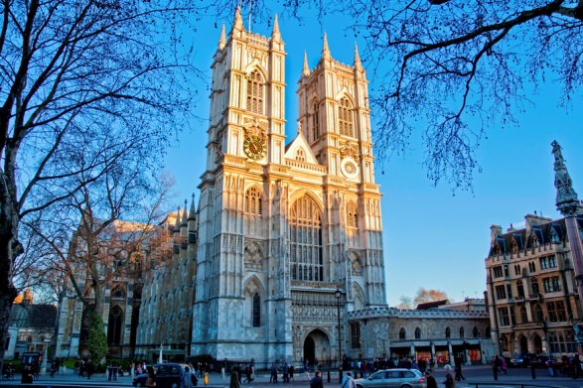
DAY1.
Your itinerary day by day.
Transfer from Heathrow Airport to the Turner Hotel by coach.
Our tour starts with the visit to the Tower of London, the old Norman fortress built by William the Conqueror. It is guarded by Beefeaters in traditional Tudor Uniforms.
We next admire Tower Bridge on the river Thames. It is a bridge which can be raised to let ships pass through.
Then we reach to Westminster Abbey, one of the oldest buildings in London and one of the most important religious Centres in the country.
After the visit to Westminster Abbey we have packed lunch and 30-minute is break.
Our tour proceeds towards the Houses of Parliament, which stands on the north bank of the river Thames and is the place where the House of Commons and the House of Lords meet to discuss and pass laws.
Our walking tour continues towards Big Ben, the famous clock tower.
Then we head to the London Eye, the world’s highest observation wheel from which you can get a breathtaking view of the city. After, our coach takes us to the hotel. Dinner and overnight stay at the Hotel.

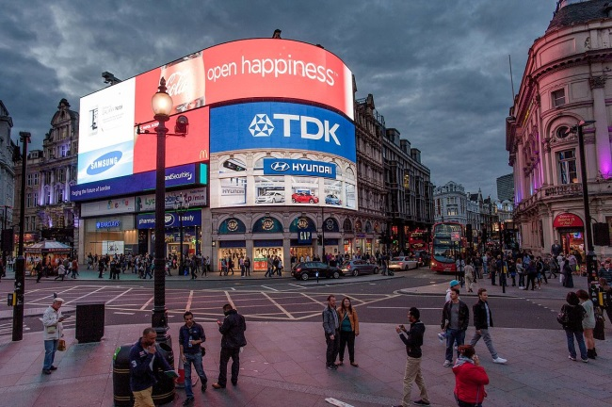
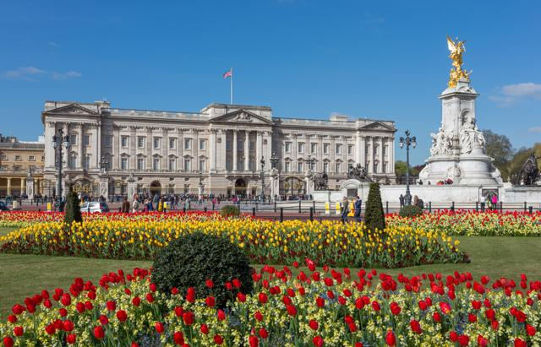
DAY2.
After breakfast, our tour starts from Buckingham Palace, the official London residence of the Queen and the Royal Family. Here you can see the Changing of the Guard at the gates of Buckingham Palace.
Our itinerary continues to Piccadilly Circus, the centre of London’s entertainment world. In this area there are many theatres, cinemas, restaurants, discos and night clubs. Its landmark is the statue of Eros.
We can have lunch in a typical restaurant.
Then we head for Hyde Park, which is used for every kind of public occasion and It is the “people’s park”.
The park is divided from Kensington Gardens by the Serpentine.
After that we reach Harrods, the largest department store in Europe.
Dinner and overnight stay at the hotel.

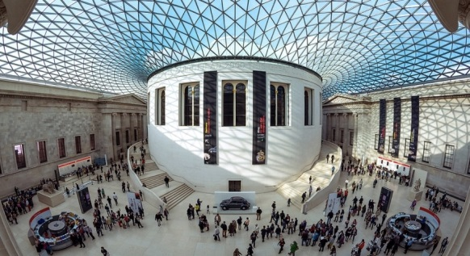
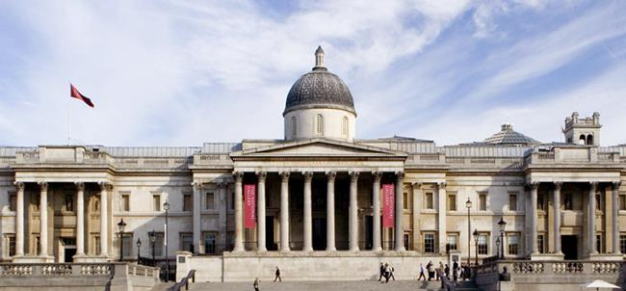
DAY3.
After breakfast we reach the British Museum, the largest museum in the world. Our tour proceeds towards the National Gallery, which stands on the north side of Trafalgar Square. It contains a collection of paintings from the 13th century to this century. Then we reach Trafalgar Square. Departure from Heathrow Airport. Arrival at Florence Airport before dinner.

