Trip to London
London is a beautiful city where you can enjoy visit the beautiful sights the city offers.

INCLUDED
- Arrival at Gatwick’s Airport
- Departure Gatwick’s Airport
- Transfer between airport and accommodation
- 2 night to beautiful London’s Hotel
- Accommodation on B&B basis
- Double rooms
- English-speaking tour guide on tour
- All sightseeing tours as mentioned
- Travel on tour by minibus or coach
- All local and airport taxes

DAY 1
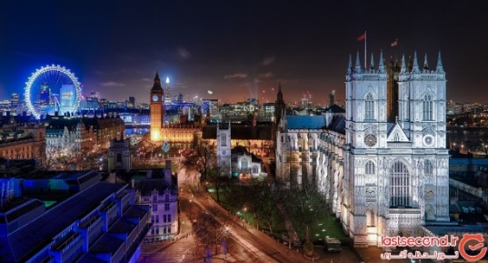
We arrive at Gatwick airport at 9 o’clock where we meet our tour guide. We reach Westminster by mini-bus where there are the houses of Parliament, the famous clock “Big Ben”, Westminster Abbey and the London Eye. Westminster Abbey is one of the oldest buildings in London and one of the most important religious centres in the country. The London Eye is the world’s highest observation wheel. Lunch is free. We can have free time. In your free time you can go shopping in the beautiful London’s street. In the afternoon we can visit two important London museums: the British Museum and the National Gallery. Later we head to Trafalgar Square where you can admire Nelson’s column. We have dinner in a typical London restaurant. Overnight stay in the hotel.

DAY 2
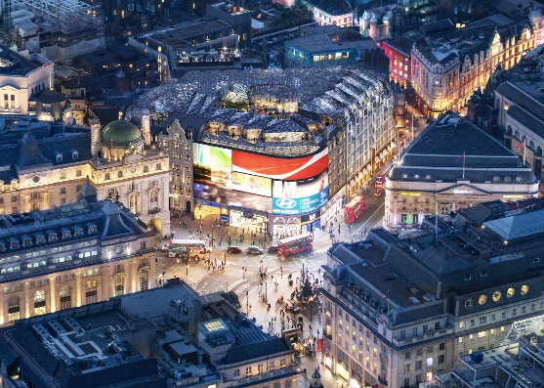
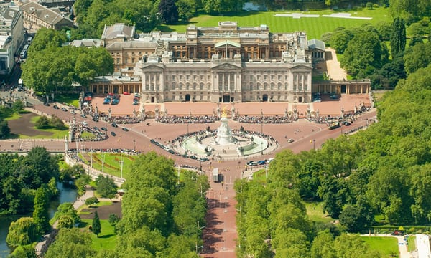
On the second day in the morning we head to Buckingham Palace where we attend the Changing of the Royal guard. It is the palace where the Royal family lives. The Changing of the Guard is at 11.30 a.m. You can have lunch in the beautiful Hyde Park. In the afternoon we reach Piccadilly Circus where you can admire the famous statue of Eros. You have free time. In your free time you can go shopping or have a nice walk. Later we visit Harrods, the famous department store. After that we have dinner in a restaurant. Overnight stay in the hotel.
DAY 3
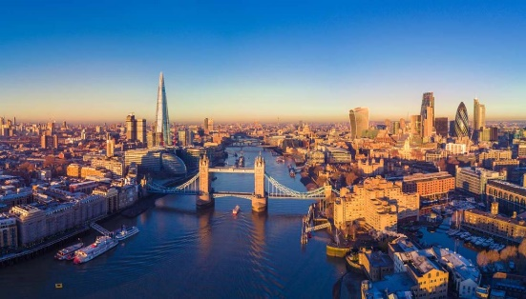
After breakfast we reach Tower Bridge and Tower of London. Tower Bridge is a drawbridge on the river Thames. The Tower of London is the old Norman fortress and it is used by the Royal Family only on state occasions. Lunch is free. Later departure from Gatwick Airport

