TREASURES OF LONDON
London is perfect for a holiday for 50 year old people.
3 DAYS
FROM
€ 590,00

WHAT’S INCLUDE.
- Departure from Pisa Airport at 8 o’ clock a.m.
- Arrival at London Airport at 10 o’ clock a.m.
- Transfer between airport and accommodation.
- 2 nights at the lovely Hotel Hilton in Hide Park. (3 days – 2 nights)
- Accommodation in HB basis.
- Double rooms.
- English – speaking tour guide on tour.
- All sightseeing tour as mentioned.
- Travel and tour by minibus or coach.
- All local and airport taxes/services charges.

PRICE: €590,00 per person.
YOUR ITINERARY DAY BY DAY
DAY 1
Departure from Pisa airport at 8.00 a.m. and arrival at Gatwick airport at 10.00 a.m.
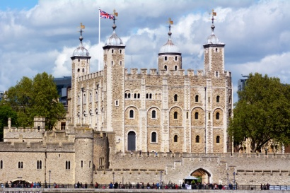
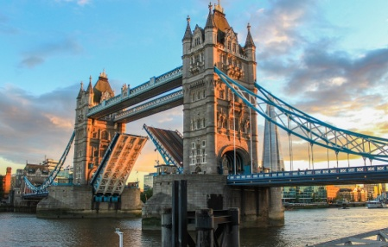
Our walking tour starts with Tower Bridge on the river Thames. It is a drawbridge, which can be raised to let ships pass through.
A few miles away we can see The Tower of London which is the Norman fortress built by William the Conqueror, the Crown Jewels are on show here. You can have lunch near the Tower in a fish and chips shop.
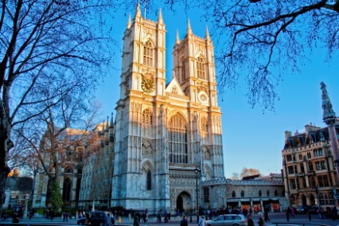
After lunch we visit the fantastic Westminister Abbey, which is one of the oldest buildings in London and a religious centre.

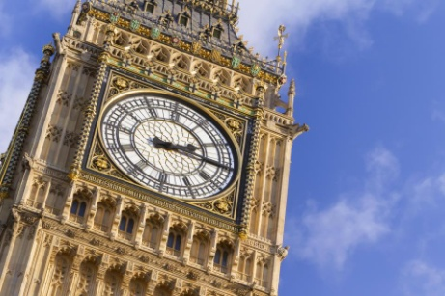
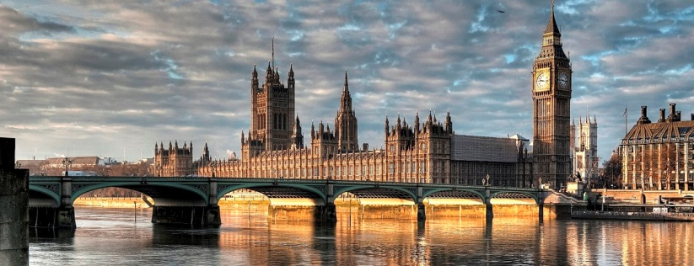
Later on we can admire the Houses of Parliament which is on the north bank of the river Thames. It is the place where the House of Commons and the Lords meet to discuss laws.
Near here we can see the famous Big Ben, which is the landmark of London. This building includes a clock tower and a bell.
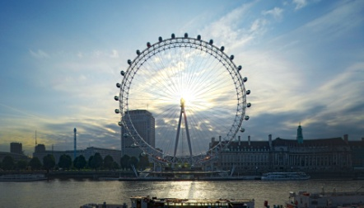
If it is a sunny day, we can’t miss the opportunity to have a flight on the London Eye the panoramic wheel which is 135 metres tall.
Overnight stay at the Hotel.
DAY 2
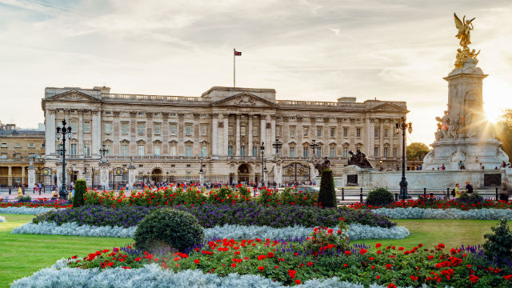
Today after breakfast we head off to Buckingham Palace, which is the residence of the Queen and the Royal Family, where you can watch the famous Changing of the guard at 11.30 a.m.
After this short visit we reach Piccadilly Circus, the centre of London’s entertainment world. Here you have time for shopping and you can have lunch in a café like “Jewel Piccadilly” a beautiful and good café.
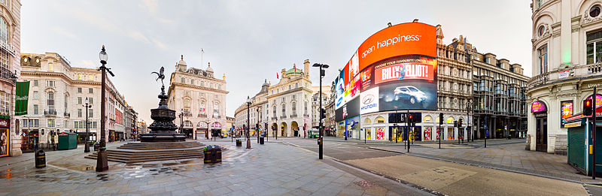

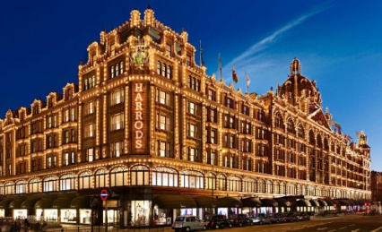
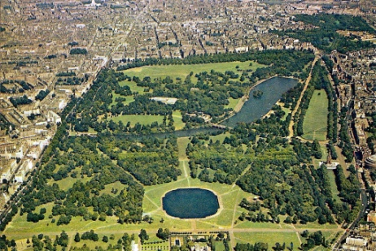
Afterwards we will reach Hyde Park, which is used for every kind of public occasion. Ere you can walk in the green, have picnics, row boots, go horse-riding, feel and watch animals. The corner near Marble Arch is known as Speaker’s Corner.

Later on, you can go shopping at Harrods a famous department stores which is the official London shop of the Royal Family. You can have dinner in Selfridges in Oxford Street where you can eat something at the restaurant “The Roof Deck”.
Overnight stay at the Hotel.

DAY 3.
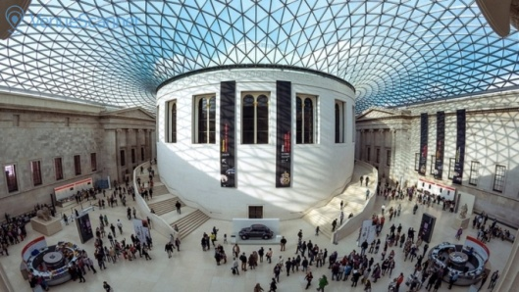
Today we visit the British Museum, which is the largest and richest museum in the world. Inside there are the Egyptian Galleries. Here we have lunch in a restaurant in Russel Street called “Marquess of Anglesey”.
After, from here it is easy to reach Trafalgar Square, which was named after Horatio Nelson’s victory over Napoleon. Nelson’s column commemorates the victory. We visit the National Gallery, which contains a collection of paintings from the 13th century to this century.
Departure from Gatwick airport our post at 7 o’ clock p.m.

