IPhone 6S
Good morning, ladies and gentlemen. On behalf of Apple, I wish to welcome you to today’s presentation of our new IPhone 6S. It is a pleasure to launch this incredible product. This is the latest creation of the Apple Company.

Let’s look at its special features: it has an integrated 12 megapixel camera and it records video in 4K. It is really thin and its weight is just 143g.
There are three different storages for this article: 16, 64 and 128 GB. Furthermore, it is available in a large range of colours; it can be grey, silver, rose or gold.

As you can see, it is really smart in size but big in features! It includes IOS10 and it also has an exclusive Easy Mode that makes commonly-used applications easily accessible for all the people all over the world. If you look at this product you will really appreciate its elegance and style.

Businessmen are the target market of this product because it has been created thinking about all their needs. It is fast, practical and it is pocket-size. It is a really innovative and technological product. The price of IPhone 6S 16 GB is around €779 and the price of IPhone 6S 128 GB is €999.
If you decide to buy it today, you will receive a free rubber cover for your new smartphone!

Thank you very much for listening.
I hope to meet you in our Apple stores.

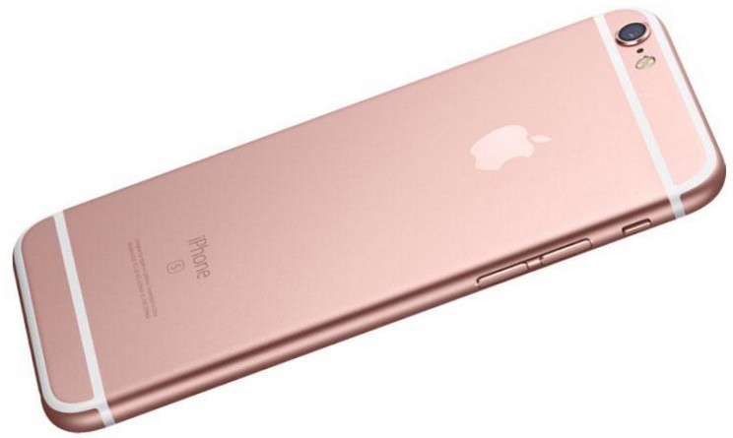
Chiara Casalini 5 AR

