Samsung Galaxy s7

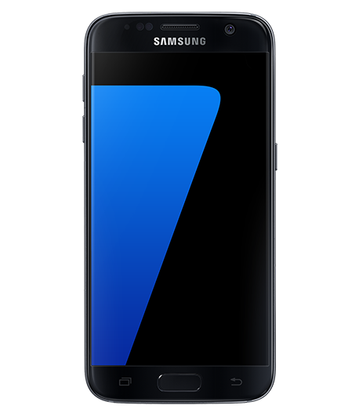
Good morning, ladies and gentlemen.
We want to launch a new product by Samsung, Samsung Galaxy s7.

This smartphone has the latest generation of advanced features. It has an Android operating system, a lithium battery of 3.000 amperes and a 12mp camera. It has an external and internal camera.

This smartphone is available in different colours: black, white, silver, pink and gold. It has a big screen in HD. It has a large memory so it can satisfy everyone's tastes.

Samsung Galaxy s7 is also water resistant thanks to its features which make it waterproof.
It has glue along the edges of its screen back gaskets for SIM slot and a membrane to prevent water from entering the speaker.

If you want to buy the latest generation mobile phone, this is the smartphone suitable for you because you can take great photos and videos. This is smartphone suitable for all ages.

The price of this smartphone ranges between 543€ and 788€.

Thank you very much for listening. I hope you enjoyed the presentation. Now, are there any questions?

Aurora Barcellona 5 AR

