THREE DAYS IN LONDON

- Arrival: Heathrow Airport
- Departure: Heathrow Airport
- 3 days (2 nights) at Royal Hotel
- Explore: Tower Bridge, Westminster Abbey, the Houses of Parliament, Big Ben, London Parks, Buckingham Palace, Piccadilly, Trafalgar Square, the British Museum, the National Gallery.
- Accommodation: Royal Hotel
- Price: 400€ per person
- English-speaking tour guide

DAY 1
Departure from Pisa airport at 8 o’clock and arrival at Heathrow airport at 10 o’clock. Transfer to the Royal Hotel by coach. Our tour starts with the visit to the Tower of London and Tower Bridge. The Tower of London is the old Norman fortress built by William the Conqueror. It is guarded by Beefeaters and the Crown Jewels are on show here. Many people were executed here. One of them was Anne Boleyn. Tower Bridge is on the river Thames. The visit will take you whole the morning. You can have lunch in a restaurant where you can taste typical London food.

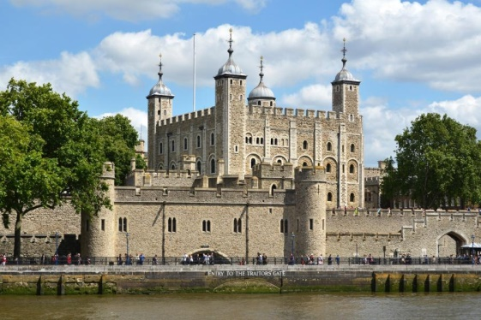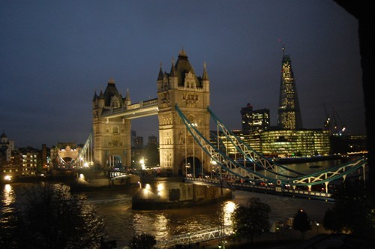

After lunch you head off to Westminster, where you can visit Westminster Abbey. The visit normally takes you over two hours. Westminster Abbey is the most important London landmark. Here you can also see the Houses of Parliament, which is composed of the House of Lords and the House of Commons. It is located on the north bank of the river Thames. You will admire the city’s main symbols: Big Ben, the clock tower of London and the London Eye, where you can enjoy the best views of the city. You have dinner at your hotel. Overnight stay at the hotel.

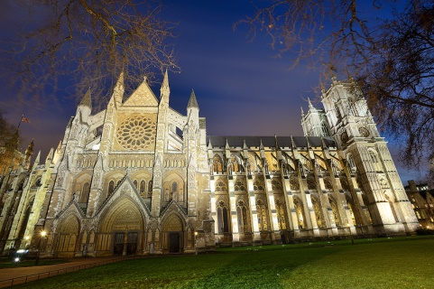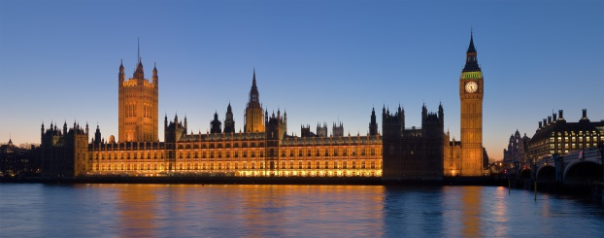

DAY 2
The second day begins with a walk in the popular Hyde Park. Walking through Green Park and St. James’s Park, you will get to Buckingham Palace, where you will have to wait until 11:30 a.m. to attend the famous ceremony of the Changing of the Guard. After that you can have lunch in a restaurant near Buckingham Palace.

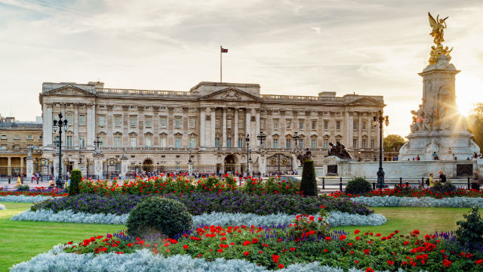
Next you head off to Piccadilly Circus, the centre of London’s entertainment world. Here there are many theatres, cinemas, restaurants, discos and nightclubs. Later you visit Harrods, a world famous department store. Piccadilly offers an excellent range of restaurants for dinner. Overnight stay at the hotel.
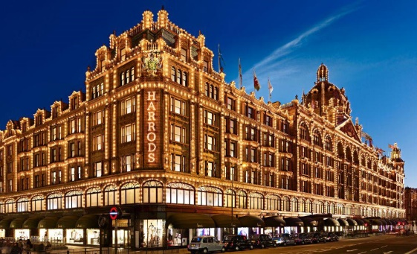
DAY 3
Today you wander in Trafalgar Square, one of the landmark squares in London. It celebrates Horatio Nelson’s victory over Napoleon in 1805. Later can you visit the British Museum, the largest and richest museum in the world it contains the work of man from prehistoric to modern times. You have lunch in a restaurant. After lunch you can visit the National Gallery, situated on the north side of Trafalgar Square. It contains a collection of paintings from the Middle Ages to the 20th century. Departure from Heathrow Airport.

