1) The Tower of Frederick II, called the Fort, is the landmark of the town. It is a 37-metre tall tower, built by Frederick II of Swabia in 1217 and was the central core of the Imperial defensive system. From its top it was possible to control the Arno Valley as far as Volterra hills, the Apennines and the sea.

Frederick Barbarossa and his grandson, Frederick II of Swabia, chose San Miniato as the seat of the Imperial financial administration for central Italy and Tuscia because the town was situated near important cities such as Florence, Volterra, Lucca and Pisa and on the famous Via Francigena, which was the main connecting route between Northern Europe and Rome in the Middle Ages.

Frederick II used the tower as a political prison and imprisoned priests, cardinals, nobles here.

Pier delle Vigne, Frederick II's Chancellor, was imprisoned in the Fort for treason until his death.

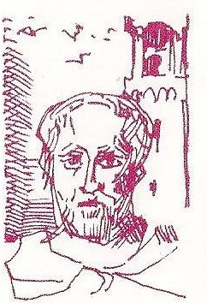
Pier delle Vigne (1190-1249) was a writer and a diplomat. He was Frederick II‘s Secretary and Chancellor. He was charged with treason and imprisoned in the Fort in San Miniato in 1248. After a year in prison he was visited by the Emperor; he was unable to defend himself so the Emperor had his eyes ripped out.

Unable to bear it, he committed suicide in the Fort.
Pier delle Vigne is mentioned in the “Divine Comedy by Dante Alighieri (13th“Canto”,“Inferno”). He reveals Dante and Virgil his identity saying “I am the man who held both the keys of Frederick’s heart…”. This means that Frederick II trusted him a lot. This sentence is written on a stone under the Fort in San Miniato.

The tower was destroyed during the Second World War and rebuilt in 1958. From its top you can admire the special ribbon-like layout of the town and a stunning landscape.

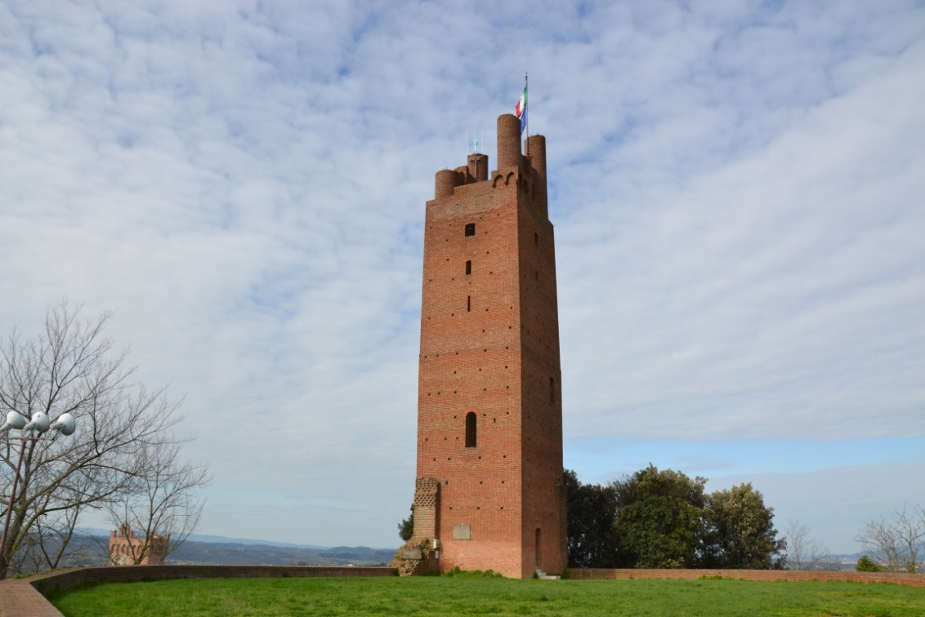

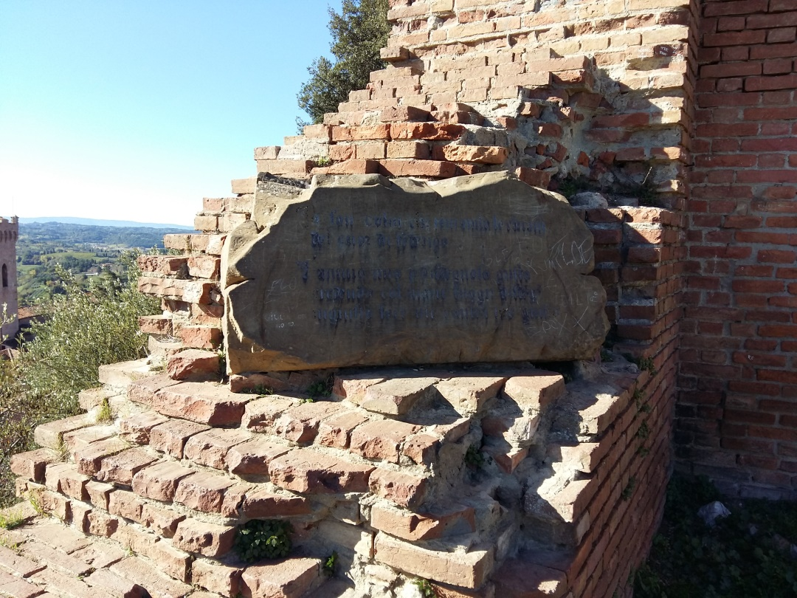

2) The Town Hall was built as the governors’ palace at the end of the 13th century.

Inside we can admire two beautiful rooms decorated with the 14th and 16th- century amazing frescoes: La Sala delle Sette Virtù and La Sala Consiliare.

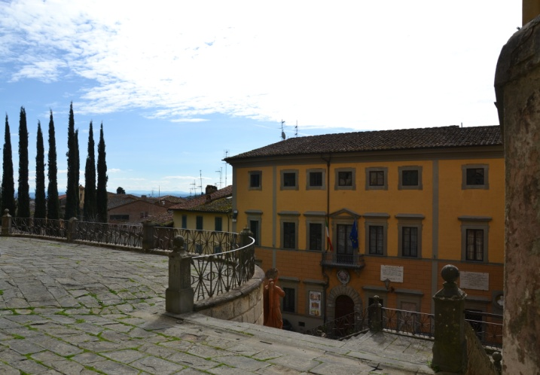
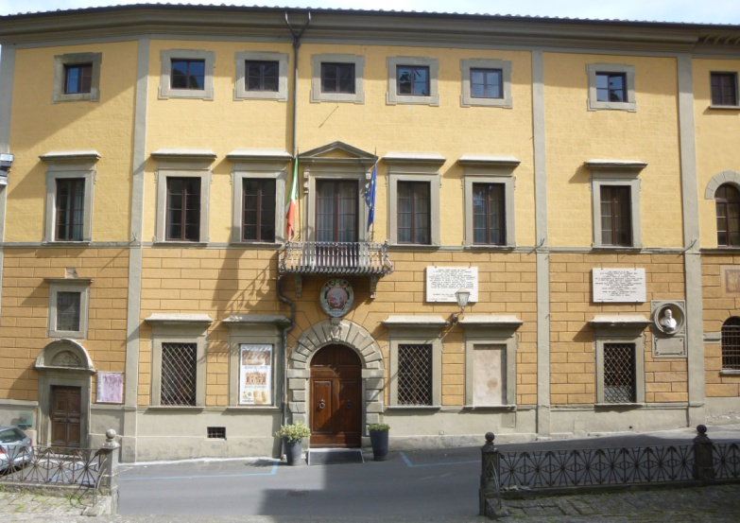
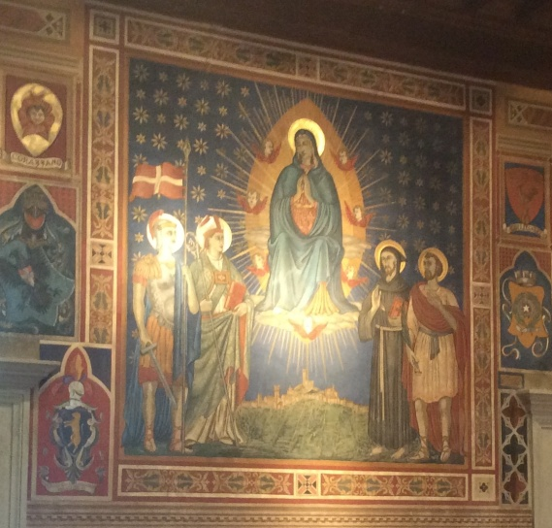
The frescoes in La Sala delle Sette Virtù were painted between the 14th and the 16th centuries. The most important fresco is the “Virgin Mary nursing her Child surrounded by the Theological and Cardinal Virtues”, attributed to Cenni di Francesco di Ser Cenni. In the middle of the painting, you can see the Virgin Mary and the Infant Jesus. Around her there are some female figures, who are symbols of the Seven Virtues. “Justice” is holding a sword in her right hand and scales in her left hand; “Prudence” is pointing to a mirror with her right hand;“Temperance” is holding a phial of wine mixed up with water in her right hand; “Fortitude” is holding a sword and is wearing a helmet; “Hope” is praying; “Charity” has got a flame in her right hand and a piece of paper in her left hand and “Faith” has a cross on her left shoulder.

La Sala Consiliare is situated next to the “Sala delle Sette Virtù” and contains Francesco Maria Galli Angelini’s famous frescoes depicting the history of San Miniato during the Middle Ages. In one of these frescoes we can see a knight riding a horse and holding a sword in his right hand.
On the right there is a parchment and on the left there is the knight's Coat of Arms. Next to this fresco, we can see a man holding a green book in his left hand and a quill in his right hand. He is wearing a red robe and a red hat.

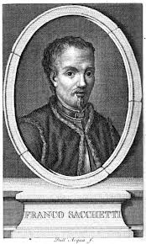
In the corner there is his family’s Coat of Arms. In another fresco we can see the Virgin Mary talking to San Miniato, San Genesio, Sant'Agostino and San Francesco. The room is decorated with frescoes depicting the Coats of Arms of famous noble families from San Miniato and famous leaders such as Francesco Sforza, Barone de’ Mangiadori and Franco Sacchetti, who was the “Podesta’(governor)of San Miniato in the 1380s and governed the town on behalf of the Florentine Republic.

Nowadays council meetings and conferences are held in the Sala Consiliare.

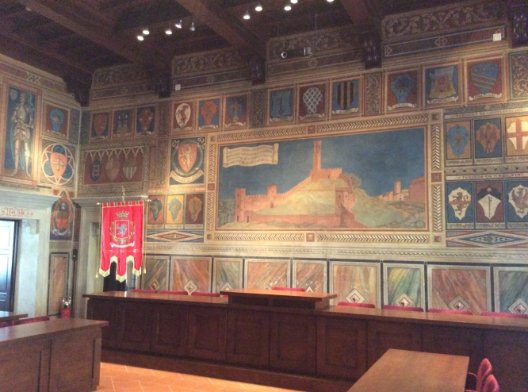

3) The Oratory of Loretino was built inside the Town Hall as the governors’ private chapel at the end of the 13th century. It became an important place of worship in the 14th century when the wooden image of the Holy Crucifix, considered to have miraculous powers, was placed here.

According to a legend, the simulacrum was brought to San Miniato by two mysterious travellers, who were probably two angels. They left it in the house of a poor widow. It was closed up in a case and it emanated an “arcane” light at night. It became a symbol of peace and love.

The veneration of the Holy Crucifix increased between 1629 and 1631 when the Bubonic Plague spread in San Miniato and Italy.

A church, the Sanctuary of the Most Holy Crucifix, was built in the 18th century in honour of the Holy Crucifix, which was placed in a tabernacle behind the main altar in 1718. The Holy Crucifix is still venerated and thought to be miraculous. This church stands between the Fort, the Cathedral and the Town Hall.

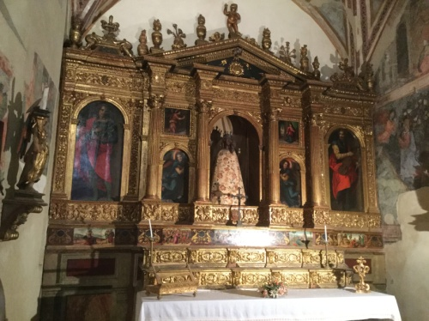
The Oratory contains decorations by Francesco Lanfranchi called “Spillo”, a magnificent altar attributed to Noferi di Antonio di Noferi and a wooden statue of the “Madonna di Loreto”, which gives the chapel its present name. The walls are decorated with 14th-century frescoes illustrating “Episodes from Jesus Christ’s Life”.

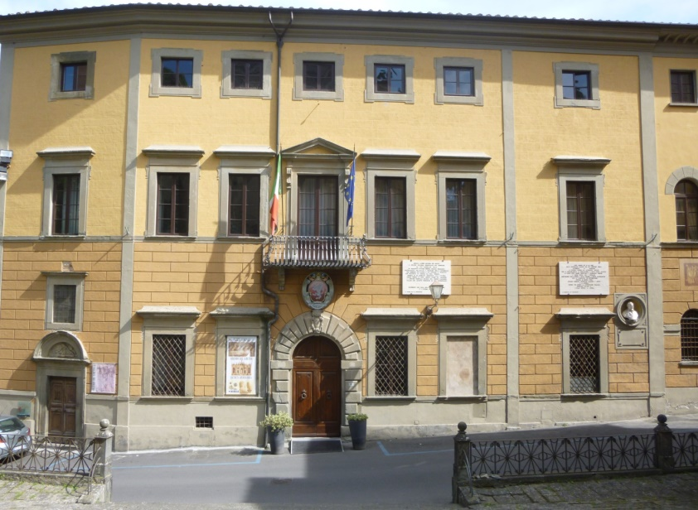

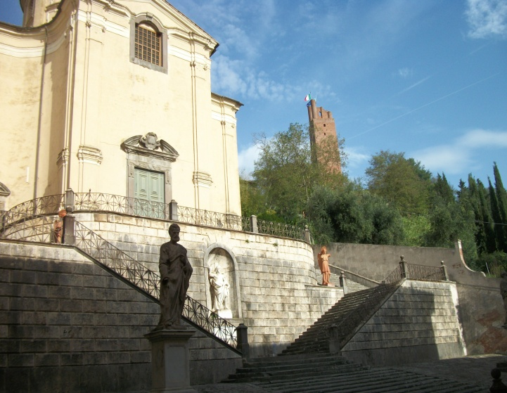

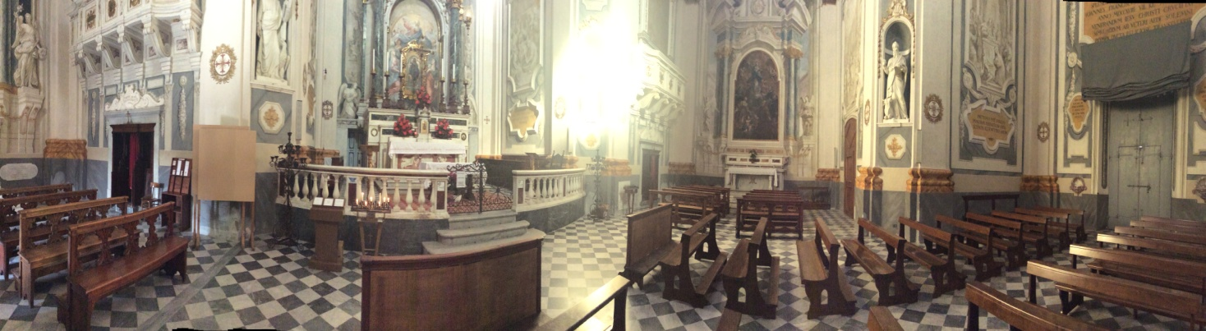

4)In Piazza del Duomo we can admire the Imperial Vicars’ Palace, which dates back to the 12th century and was Frederick II’s residence, and its Tower, which was used as a prison.
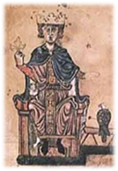
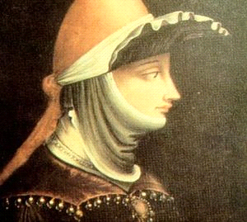
The Palace was the seat of the Imperial Vicars and emperors such as Frederick I Barbarossa, Herny IV, Ottone IV and Frederick II lived here.

Matilde di Canossa, who was the daughter of Bonifacio IV, ruler of many counties such as Reggio, Modena, Mantua, Brescia and Ferrara, and Beatrice of Lorena, one of Frederick II’s daughters, was born in this palace.
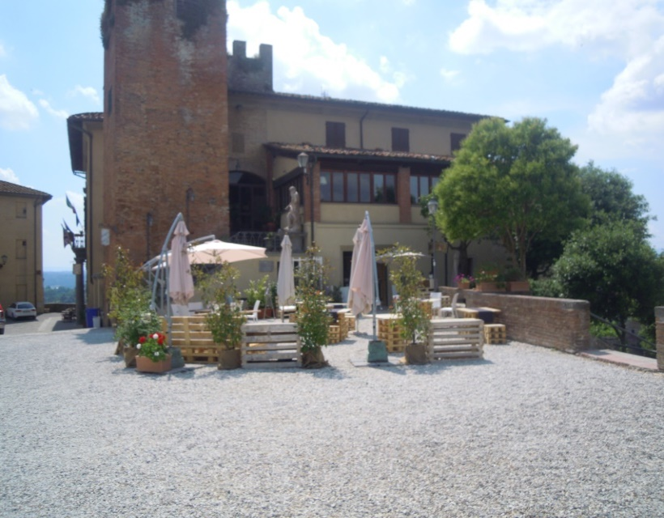
The Palace became the seat of the Florentine Court and its prison in the following centuries.

Gostanza , the witch from San Miniato, was imprisoned here.

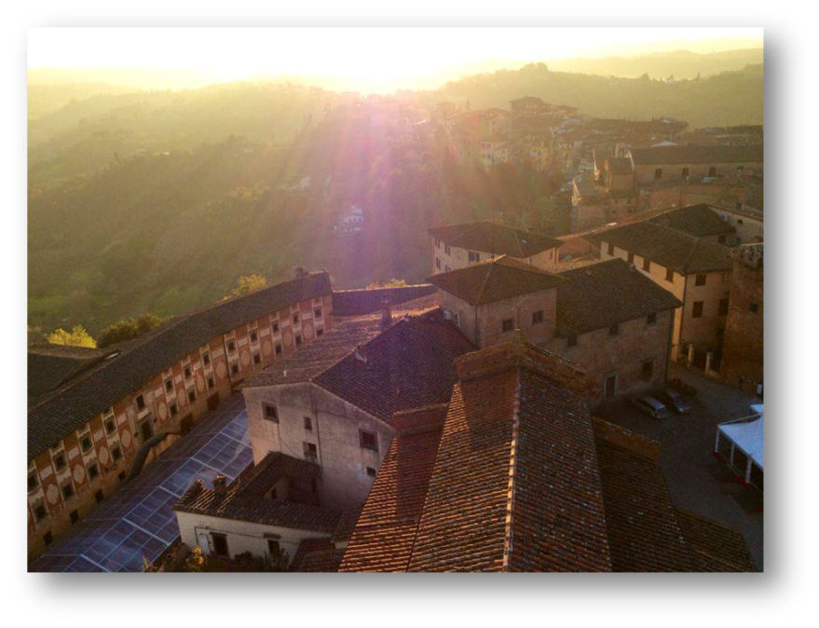

Gostanza was a 50 year-old widow who lived in San Miniato about 500 years ago. She was a poor peasant and earned her living as a midwife.

The misadventures of this woman started in the Castle of Lari, near Pisa, in 1594, when two women and two men charged Gostanza da Libbiano with provoking several babies’ death by using witchcraft.

Gostanza was interrogated in a trial, which took place in San Miniato, and she admitted she had used ointments and placed a candle on women in labour as a symbol of good luck but she denied she had provoked new-borns’ death.

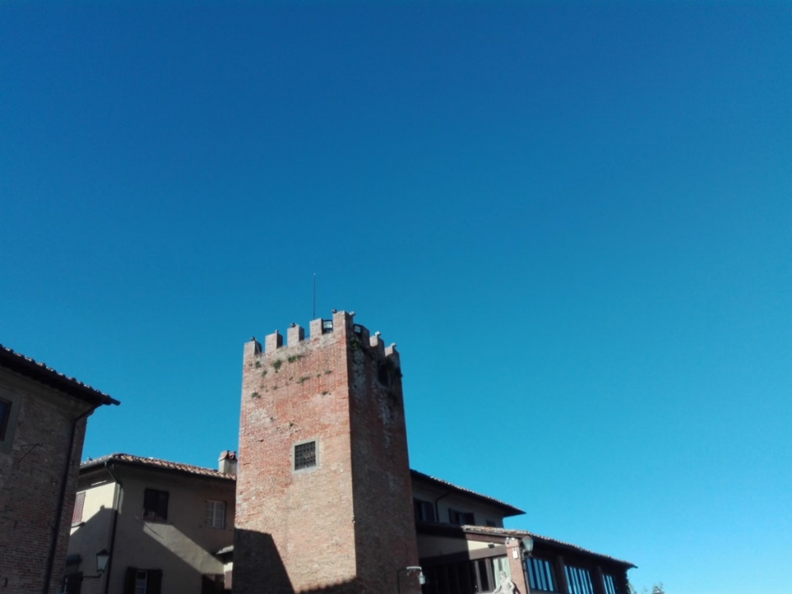

The inquisitor sentenced her to the “torture of the ropes”.
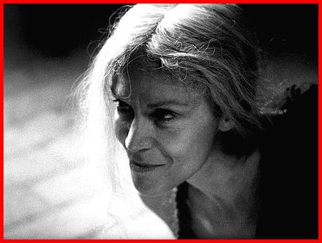
After being hung by a rope which stretched her arms she admitted she had practised witchcraft upon several people.

In the following days the poor woman began to confess more and more in order to avoid new tortures. She even admitted she had had a relationship with several demons and she had taken on the form of a black cat, sucked children’s blood and stolen and fried consecrate Hosts in order to offer them as a sacrifice to a demon called “Polletto”.
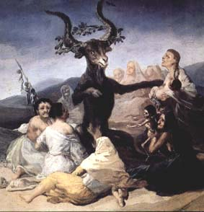
She was going to be burnt at the stake but on 19th November 1594, Dionigi da Costacciaro, a new Florentine inquisitor, realized her confessions had been invented by a human mind and not by the devil and her confessions were just lies so he decided to keep Gostanza in prison for a few days and put an end to her torture.

The inquisitor interrogated Gostanza on different occasions and finally on 24th November he asked her if she was willing to swear that her confessions were true.
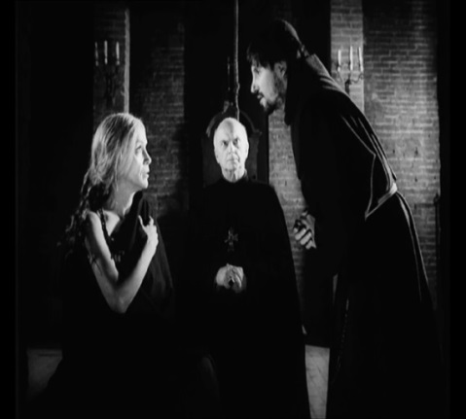
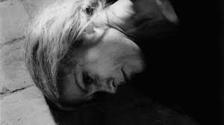

The widow explained that they were all lies and admitted she had confessed everything just in order to put an end to her torture and die.

The trial came to an end with Gostanza’s absolution and the acknowledgment of her innocence on 28th November.

The inquisitor ordered her not to use potions any longer and move to another town.

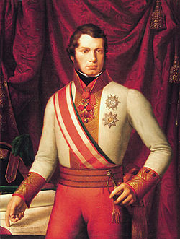
5)Piazza Bonaparte is a picturesque triangular square flanked by ancient palaces built by noble families from San Miniato between the 16th and the 18th centuries.
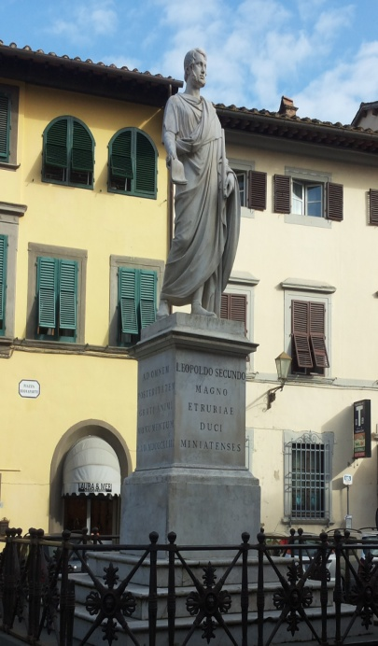

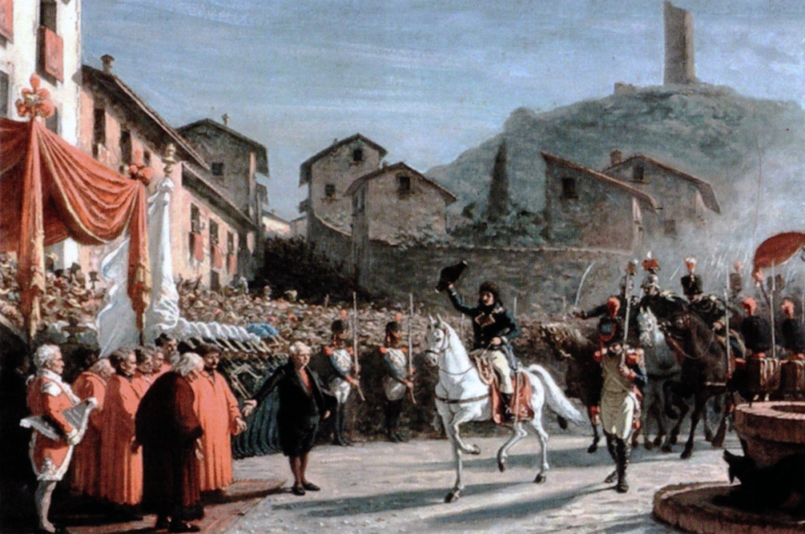

In this square we can admire a marble monument dedicated to the Grand Duke of Tuscany, Leopoldo II also called Canapone (1824-1859),who was called "Canapone" for his hair colour. He set up a lot of institutions such as state schools, the railway station and the Court of Justice in San Miniato.

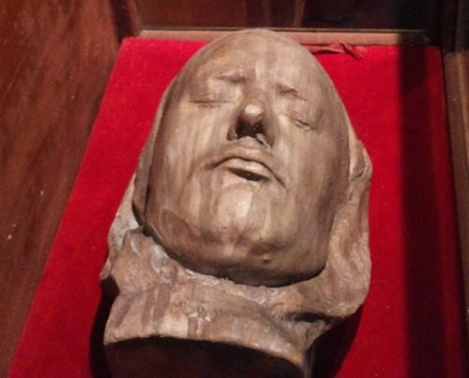
We can also admire Bonaparte Palace, which was the residence of the Bonaparte family. Napoleon Bonaparte, the famous Emperor of France, came to San Miniato during his campaign in Italy in 1796 in order to meet Filippo Bonaparte, who was a priest and the Bonaparte family’s last descendant and stayed in this palace as his guest. Napoleon’s family was of Italian noble origins and they had most of their properties in San Miniato.

Napoleon’s funeral mask is housed in Migliorati Palace in San Miniato.

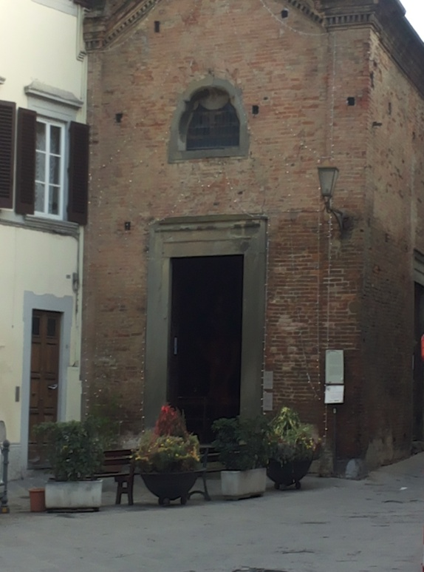
The Saints Sebastian and Rocco’s Church, which was the Bonaparte family’s chapel and houses Saint Rocco’s relics, is worth a visit. It dates back to the 15th century and was built on the ruins of a more ancient oratory.

This small one-nave church is dedicated to Saint Rocco, who is the patron saint of pilgrims, and it is one of the main stops along the Via Francigena, which was the pilgrimage route from Canterbury to Rome in the Middle Ages and was used not only by simple pilgrims, but also by Kings, Popes and Princes.
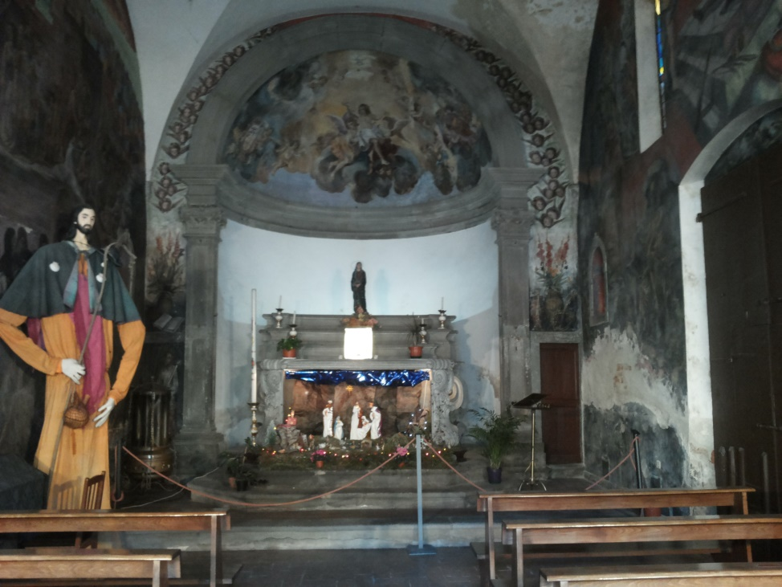

The Via Francigena connected abbeys, linking the sacred places of the Christian world and was an important route for men and goods which contributed to the great rebirth of European commerce.

Nowadays the Via Francigena is a journey through the Italian landscape and makes modern pilgrims really understand the landscape, the past and the present. The journey turns into a gradual immersion in the roots of our culture, in which changes in the landscape, small and great works of art, the people we meet along the road, make us understand the essence of our heritage.

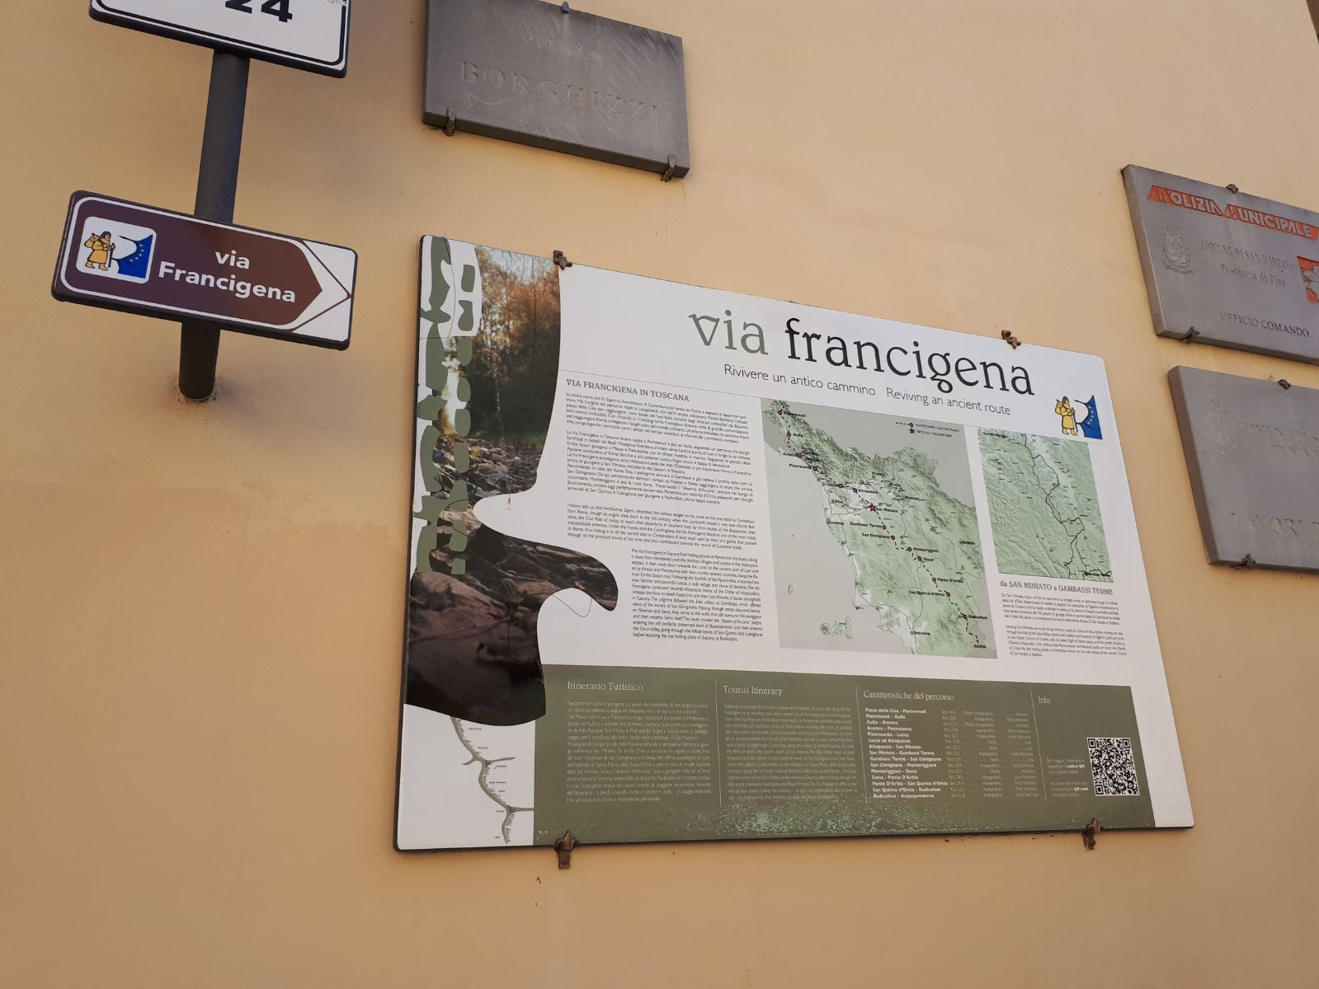

Piazza Bonaparte was once used for weekly markets and it was also called “Piazza Dei Polli”(Chickens’ Square) because meat and poultry were sold here.

Nowadays traditional games, exhibitions, and events take place in this square especially in August when Saint Rocco is celebrated .

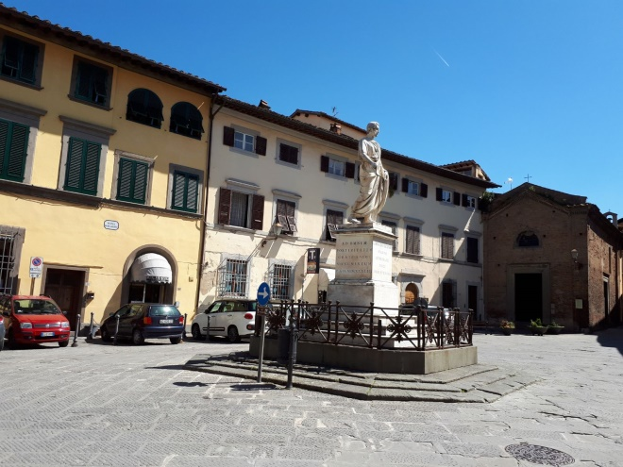
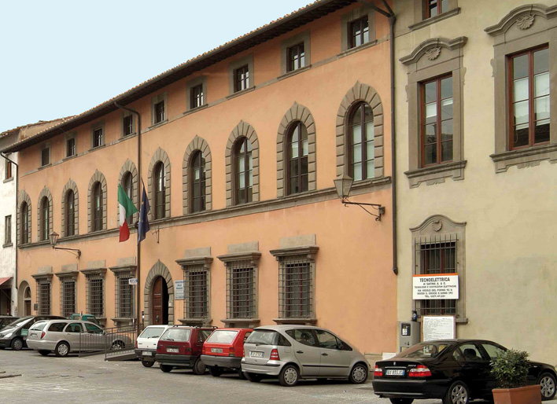

Created by
IT CATTANEO SAN MINIATO (PISA)
ITALY
