SIENA

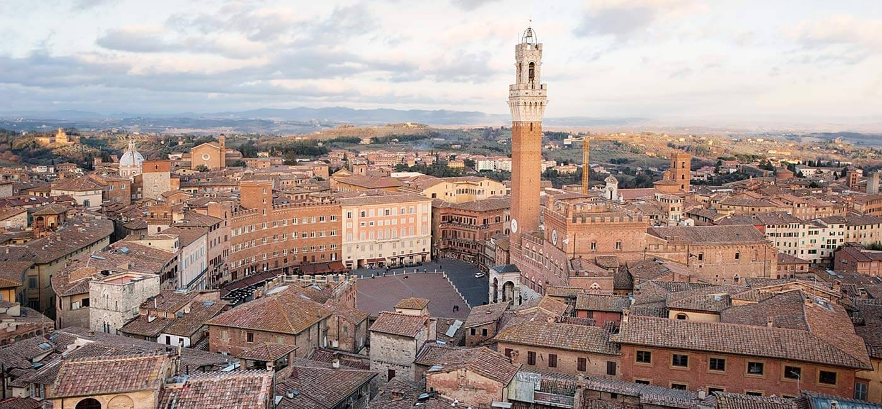
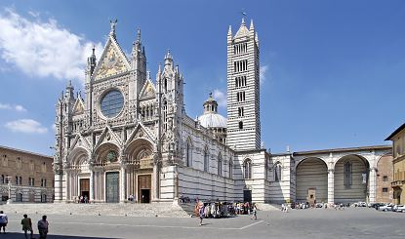
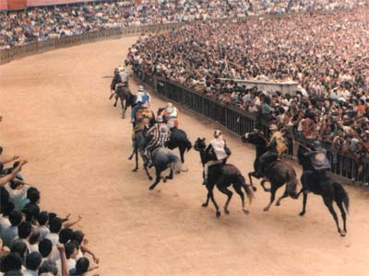
Siena is a famous Medieval city, located in the heart of Tuscany. It is one of the most popular and visited cities in Tuscany as it is extremely rich in history and art and with strong local traditions such as the famous Palio di Siena, the biggest annual event taking place in the city twice a year in summer.
FOCUS ON

HISTORY

The legend says that Siena was founded by Senius and Ascanius, sons of Remus, of the famous twins Romulus and Remus, who founded Rome. Statues of the wolf feeding the twins are spotted throughout Siena. In 30 A.D. the Romans established a military outpost called Siena, which developed into a busy little trading post in the following years.

The Lombards arrived in the 6th century A.D. , and the Franks also governed the city. Great works were carried out, the most important was the famous Via Francigena, the road which linked Rome to France , used by pilgrims and travellers; this greatly increased Siena’s importance. The Church was actively involved in governing the city, especially between the 9th and 11th centuries, but later the Sienese people claimed their right to govern and administer the city.

Siena’s economic and military power grew enormously and inevitably friction grew between Siena and Florence, as both cities tried to enlarge their territory. There were many battles between the two cities between the 13th and 15th centuries. Eventually Siena was incorporated into the Florentine territory and administration.

Despite both external disputes with neighbours and internal disputes over government, in the years from 1150 to 1300, great artists were discovered and the city was adorned with beautiful monuments such as the Cathedral, “Palazzo Pubblico” and “Torre del Mangia”.

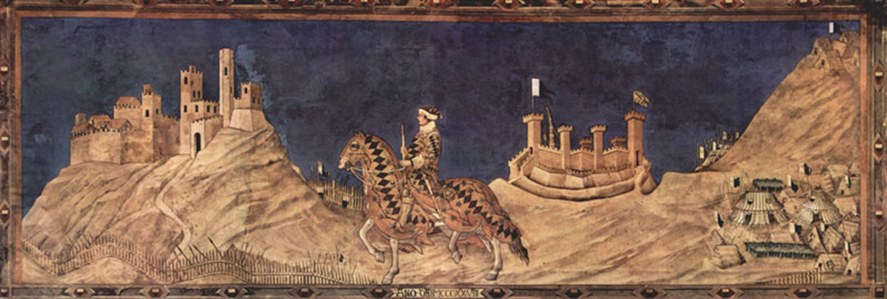
From the 14th century to the 19th century Siena had rulers like Emperor Charles V and Cosimo I de’ Medici. Siena grew in economic power, with the famous bank “Monte dei Paschi di Siena” giving employment and security to the citizens throughout the ages. When Italy formed a Republic, Siena became part of the region of Tuscany and today it prospers for a combination of finance and tourism thanks to its beautiful artistic heritage.
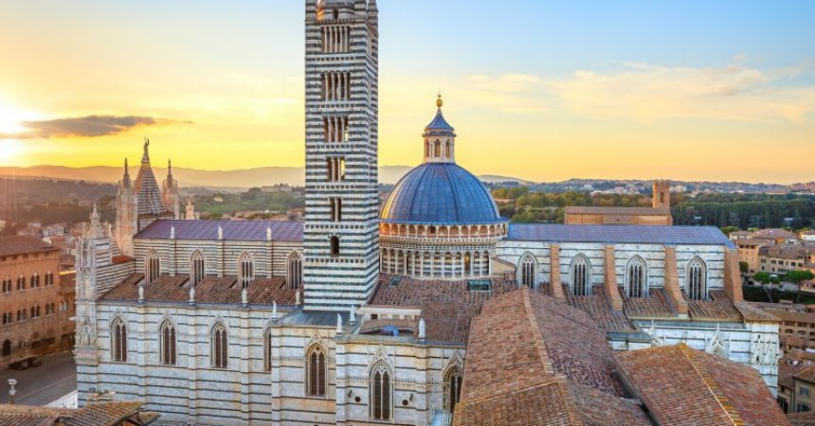
Our walking tour starts with the 13th-century Cathedral of Santa Maria Assunta, which is one of the greatest cathedrals in Italy with its spectacular mixture of sculptures, paintings and Romanesque-Gothic architecture.

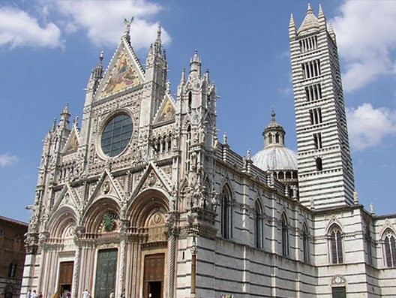
Don’t miss its marble floor with panels by various artists representing scenes from the Old and New Testaments and the Gothic Pulpit by Arnolfo di Cambio and Nicola Pisano. Inside the cathedral the pictorial effect of the black and white marble stripes on the walls and columns is outstanding. The colours of the civic Coat of Arms of Siena are black and white.
The cathedral house works of art by Donatello, Nicola Pisano, Michelangelo and Pinturicchio.

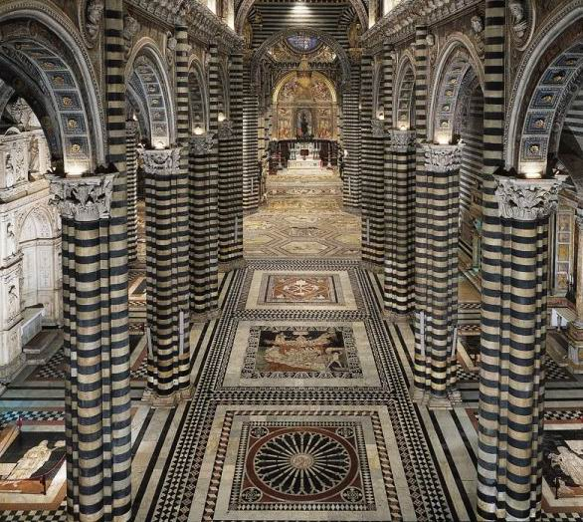
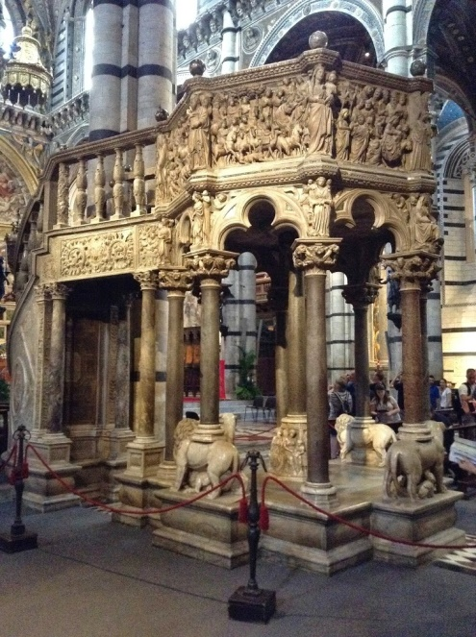

Next to the Cathedral there is a column with the she-wolf breast feeding Romulus and Remus, symbol of Siena.
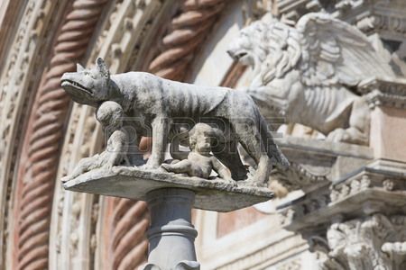

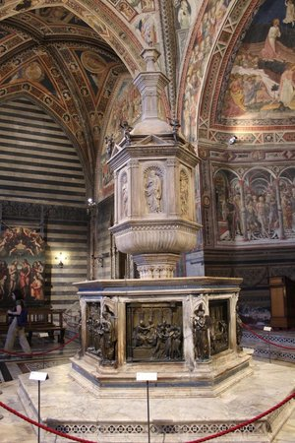
Leaving the Cathedral behind us we reach the Baptistery, which serves as its crypt. It is dedicated to St. John the Baptist and was built between 1316 and 1325 and it has a Gothic façade. Inside you can admire the Baptismal font by Jacopo della Quercia, a masterpiece of Tuscan sculpture and frescoes by Renaissance Sienese artists.
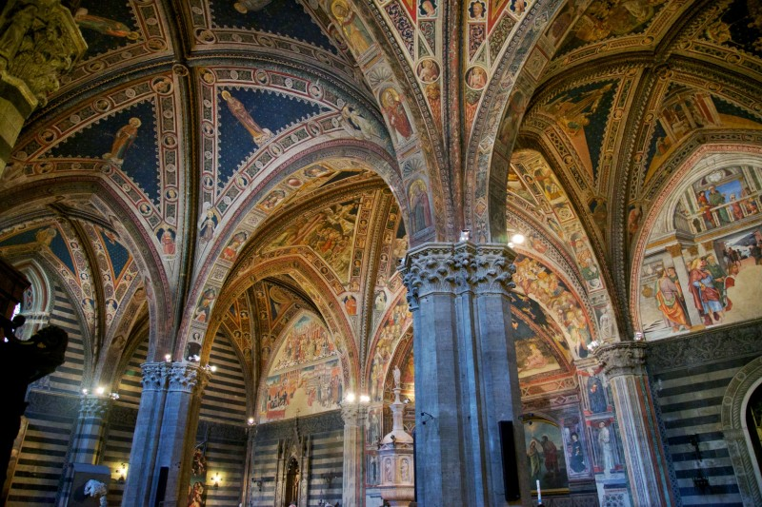

During the walking tour we stop for lunch at the typical restaurant, Antica Salumeria Salvini, where you can taste typical Tuscan dishes. You can start off with an appetizer of mixed “salami” and “crostini”. Then you can taste “pici”, “ravioli” or “pappardelle alla lepre” as a first course and after that you can choose Chianina steak and “panforte” and some “ricciarelli”.

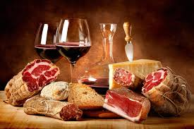
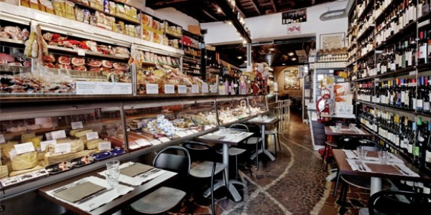

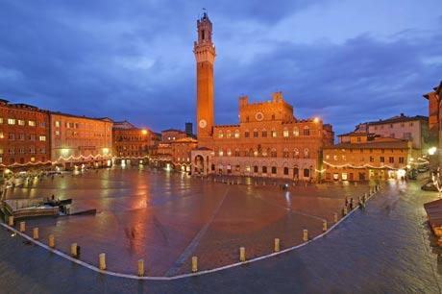
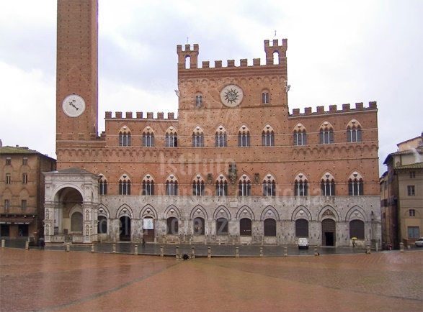
After lunch we continue our tour with the visit to Piazza del Campo with its marvellous Palazzo Pubblico, which is considered one of the finest examples of Gothic architecture, and the breath-taking Torre del Mangia (102 metres tall). Piazza del Campo is one of greatest Medieval squares in Europe.

Palazzo Pubblico was started at the end of the 13th century and it was subsequently completed with the lovely Torre del Mangia. In the past it was the residence of the city’s “Signoria”, and Podestà, and now it is now the seat of the Town Council.

The building houses the Civic Museum, rich in numerous treasures and frescoes such as“the Allegory of the Good and Bad Government” by Lorenzetti, which is the largest secular painting cycle of the Middle Ages, and a political manifesto in which the painter depicts two opposing methods of government along with their consequences.

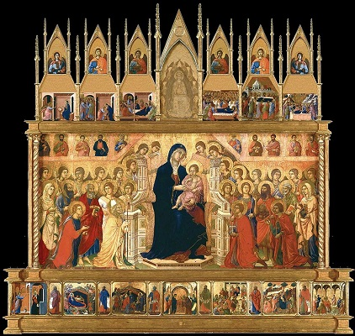
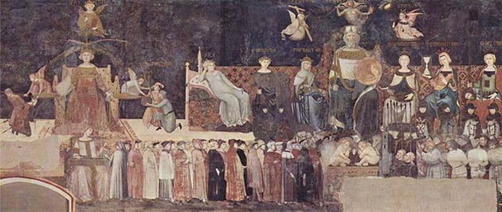
The spectacular “Sala del Mappamondo”, formerly used as the meeting room for the General Council of the Republic of Siena, is worth a visit. The room takes its name after a rotating map painted by Ambrogio Lorenzetti, which showed the lands governed by the city. It houses Maestà”, a wonderful fresco“ by Simone Martini. Piazza del Campo is still used for the famous Palio, which is one of the most popular Italian events.
EVENT NOT TO BE MISSED

PALIO DI SIENA

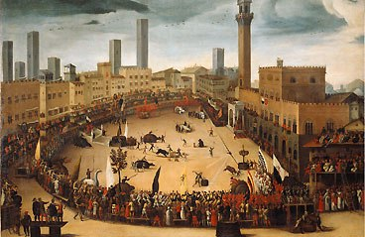
The “Palio” is a horse race, which takes place on 2nd July and on 16th August every year. The “Palio” celebrates the miraculous apparition of the Virgin Mary and is a historical tradition involving the famous “Contrade” (City Wards) of Siena (districts into which the city is divided). Each city ward has its own government, oratory, emblems and colours, official representatives, patron saints, a limited district and a population consisting of all those people born within the topographic limits of the districts. Originally there were about fifty-nine city wards, now there are only seventeen, ten of which participate in each race. The race involves circling Piazza del Campo. Ten horses and riders represent ten of the seventeen city wards. , which are Aquila (Eagle), Bruco (Caterpillar), Chiocciola (Snail), Civetta (Little Owl), Drago (Dragon), Giraffa (Giraffe), Istrice (Crested porcupine), Liocorno (Unicorn), Lupa (Female Wolf), Nicchio (Seashell), Oca (goose), Onda (Wave), Pantera (Black Panther), Selva (Forest), Tartaruga (Tortoise), Torre (Tower) and Valdimontone (literally, “ Valley of the Ram”). The winner is awarded a banner of painted silk, or “palio”, which is newly created by a different artist for each race.A magnificent “Corteo Storico” precedes the race, which attracts visitors and spectators from all over the world. The “Palio” is an unforgettable experience for Italian and foreign tourists.
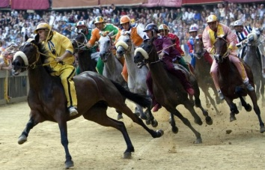

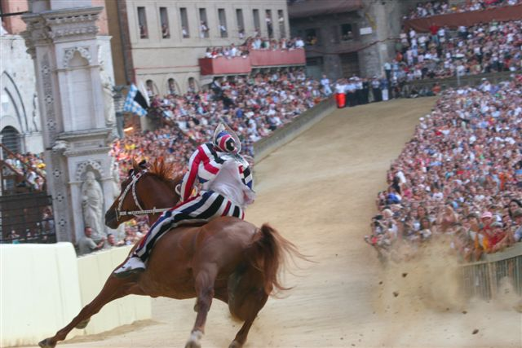
FOCUS ON

PANFORTE
This is the favourite and most famous pastry made in Siena that has also given us cavalucci, ricciarelli and copate.

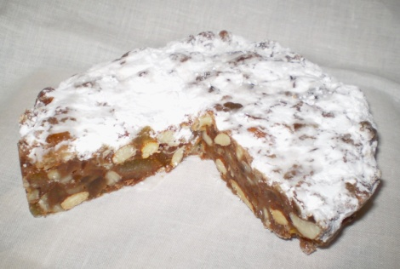
Recipe:Shell the almonds and crush the bitter almonds and half the others together.Mix the rest of the sweet almonds with the pine nuts. Heat the honey in a saucepan over a very low flame until it is transparent. Remove the pan from the stove and add the rest of the ingredients, stirring gently until completely blended. Pour the mixture into a floured pie plate and bake at 160° C\320°F for 30 minutes. The panforte should be dark, firm and not more than one finger thick. Cool and dust with confectioner’s sugar before serving.

RICCIARELLI
Recipe: Powder the almonds with a meat hammer or a food grinder. Add most of the powdered sugar and mix well, then whip the egg white until stiff, and delicately fold it into the almond paste, one tablespoon at a time. When the paste becomes too stiff to be mixed with a spoon, work it with your hands on the kitchen pastry board dusted with a little powdered sugar. Knead until the paste is smooth, then roll out with the rolling pin to a thickness of about 1- 1.5 cm, and cut into discs the size of the confectionery wafers on an oven tray and then place an almond paste disc on each wafer. Cover with a tea-cloth and let rest for one hour in a cool place. Bake in a preheated oven at 16o° C for about 30 minutes, without letting the biscuits brown. Remove from the oven , allow to cool and serve with a sprinkling of powdered sugar after having trimmed off any excess wafer protruding from the almond discs.

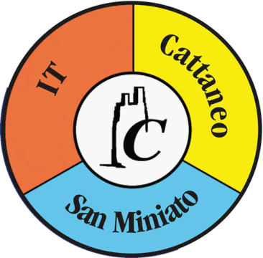

I.T. CATTANEO
SAN MINIATO (PISA)
ITALY

Anno Scolastico 2017-2018

.

